ACC, HIMSS and RSNA
Integrating the Healthcare Enterprise



IHE Patient Care Coordination
Technical Framework
Volumes 1, 2 & 3

2005-2006

Public Comment Draft July 22, 2005
Comments due August 22, 2005

Thank you for participating in this document review!
This draft of the Patient Care Coordination Technical Framework V1.0 is submitted for Public Comment between July 22, 2005 and August 22, 2005, per the scheduled announced in May 2005.
As you read this document, there are known outstanding issues. Please keep these questions in mind in addition to any other feedback to the Technical Committee during the public comment period.
- Should the support by Document Source and Consumers of the Notification of Document Availability (NAV) Profile be required or optional? Required.
- Should XDS Folders in the Registry be used? How? One suggestion is that the Referral use case should create a folder for organizing subsequent communication in a collaborative referral. We have not constrained the use of folders.
- What is the right minimum list of sections in the content profile? Specifically:
  - Is the granularity of sections appropriate? For example, currently there is no separate LOINC code for outpatient procedures, so this has been combined with Summary Tests. Similarly Discharge Disposition has been lumped into the Care Plan. Is this adequate?
  - Is the definition of “Required” adequate?
- We have limited the scope of the medication data import to support simple sigs. Details of split dosing, sliding scale dosing, or weight based dosing are not presently supported. We expect this would be supported in future revisions.
- We grouped Surgical Procedures under Studies and Reports to simplify. We would like your comments on this.
- We are not aware of specific state and local requirements for completion of referral forms; please comment on what these might be.
- Should the Transaction PCC-1 be described as limited to Provide and Register (not include Notification Send) and the requirement to send a Notification simply listed in the expected action of PCC-1.

Comments shall be submitted before August 22, 2005 to:
http://forums.rsna.org under the “IHE” forum
Select the “Patient Care Coordination Supplements for Public Review” sub-forum.
The IHE Patient Care Coordination Technical Committee will address these comments and publish the Trial Implementation Draft version on September 5, 2005.
Table of Content
Volumes 1, 2 and 3
Foreword 4
1.1 Editors 5
2 Preface 6
2.1 How this document is organized 6
Volume 1
1 Introduction 1
1.1 Overview of the Technical Framework 1
1.2 Overview of the Patient Care Coordination Volume 1 2
1.3 Audience 3
1.4 Relationship to Standards 3
1.5 Relationship to Real-world Architectures 3
1.6 Conventions 4
1.7 Scope of Changes Introduced in the Current Year 5
1.8 Comments 6
1.9 Copyright Permission 6
1.10 IHE Technical Framework Development and Maintenance Process 6
2 Patient Care Coordination Integration Profiles 8
2.1 Dependencies among Integration Profiles 8
2.2 Integration Profiles Overview 9
2.3 Product Implementations 10
3 Cross-Enterprise Sharing of Medical Summaries (XDS-MS) Integration Profile 11
3.1 Scope 11
3.2 Related Information for the Reader 12
3.3 Actors/Transactions 13
3.4 Actors 14
3.5 Transactions 15
3.6 XDS-MS Integration Profile Options 16
3.7 Grouping with Other Profile Actors 19
3.8 XDS-MS Integration Profile Process Flow 20
3.9 Security Considerations 25
GLOSSARY 32
Volume 2
1 Introduction 3
1.1 Overview of Technical Framework 3
1.2 Overview of Volume 2 3
1.3 Audience 4
1.4 Relationship to Standards 4
1.5 Relationship to Real-world Architectures 4
1.6 Comments 5
1.7 Copyright Permission 5
2 Conventions 6
2.1 The Generic IHE Transaction Model 6
3 Role of this Volume in the Technical Framework 8
4 IHE Transactions 9
4.1 Provide and Register Document Set 9
4.2 Register Document Set 12
4.3 Retrieve Document 15
Volume 3
1 Introduction 1
1.1 Overview of Technical Framework 1
1.2 Overview of Volume 3 1
1.3 Audience 2
1.4 Relationship to Standards 2
1.5 Relationship to Real-world Architectures 2
1.6 Comments 3
1.7 Copyright Permission 3
2 Conventions 4
3 Role of this Volume in the Technical Framework 5
4 Medical Summary Content Profile – US Realm 6
4.1 Related Content Profiles 6
4.2 Context for Content Profile 6
4.3 Purpose of the Medical Summary Content Profile 7
4.4 Source Mapping 11
4.5 Content Standards 16
4.6 Document Consumer Processing 21
4.7 Configuration 21
Appendix A – HL7 Patient Care Structures within CDA R2……………………………………22

Foreword
Integrating the Healthcare Enterprise (IHE) is an initiative designed to stimulate the integration of the information systems that support modern healthcare institutions. Its fundamental objective is to ensure that in the care of patients all required information for medical decisions is both correct and available to healthcare professionals. The IHE initiative is both a process and a forum for encouraging integration efforts. It defines a technical framework for the implementation of established messaging standards to achieve specific clinical goals. It includes a rigorous testing process for the implementation of this framework. And it organizes educational sessions and exhibits at major meetings of medical professionals to demonstrate the benefits of this framework and encourage its adoption by industry and users.
The approach employed in the IHE initiative is not to define new integration standards, but rather to support the use of existing standards, HL7, DICOM, IETF, and others, as appropriate in their respective domains in an integrated manner, defining configuration choices when necessary. When clarifications or extensions to existing standards are necessary, IHE refers recommendations to the relevant standards bodies.
This initiative has numerous sponsors and supporting organizations in different medical specialty domains and geographical regions. In North America the primary sponsors are the American College of Cardiology (ACC), the Healthcare Information and Management Systems Society (HIMSS) and the Radiological Society of North America (RSNA). IHE Canada has also been formed. IHE Europe (IHE-EUR) is supported by a large coalition of organizations including the European Association of Radiology (EAR) and European Congress of Radiologists (ECR), the Coordination Committee of the Radiological and Electromedical Industries (COCIR), Deutsche Röntgengesellschaft (DRG), the EuroPACS Association, Groupement pour la Modernisation du Système d'Information Hospitalier (GMSIH), Société Francaise de Radiologie (SFR), and Società Italiana di Radiologia Medica (SIRM). In Japan IHE-J is sponsored by the Ministry of Economy, Trade, and Industry (METI); the Ministry of Health, Labor, and Welfare; and MEDIS-DC; cooperating organizations include the Japan Industries Association of Radiological Systems (JIRA), the Japan Association of Healthcare Information Systems Industry (JAHIS), Japan Radiological Society (JRS), Japan Society of Radiological Technology (JSRT), and the Japan Association of Medical Informatics (JAMI). Other organizations representing healthcare professionals are actively involved and others are invited to join in the expansion of the IHE process across disciplinary and geographic boundaries.
The IHE Technical Frameworks for the various domains (Patient Care Coordination, IT Infrastructure, Cardiology, Laboratory, Radiology, etc.) defines specific implementations of established standards to achieve integration goals that promote appropriate sharing of medical information to support optimal patient care. It is expanded annually, after a period of public review, and maintained regularly through the identification and correction of errata. The current version for these Technical Frameworks may be found at www.ihe.net.
The IHE Technical Framework identifies a subset of the functional components of the healthcare enterprise, called IHE Actors, and specifies their interactions in terms of a set of coordinated, standards-based transactions. It describes this body of transactions in progressively greater depth. The volume I provides a high-level view of IHE functionality, showing the transactions organized into functional units called Integration Profiles that highlight their capacity to address specific clinical needs. The subsequent volumes provide detailed technical descriptions of each IHE transaction.

Editors
Landen Bain, CDISC
Keith W. Boone, Dictaphone
George Cole, AllScripts
Larry McKnight, MD, Siemens
Charles Parisot, GE Healthcare
Dan Russler, MD, McKesson

Preface
This profile defines the relevant standards and constraints on those standards in order to implement a specific use case for the transfer of information between systems.

How this document is organized
This document is organized into 3 volumes as follows:

Volume 1 – Integration Profile Overview
This volume is provided as a high level overview of the profile including descriptions of the use case, the actors involved, the process flow, and dependencies on other standards and IHE profiles. It is of interest to care providers, vendors’ management and technical architects and to all users of the profile

Volume 2 – Transactions
This volume is intended as a technical reference for the implementation of specific transactions in the use case including references to the relevant standards, constraints, and interaction diagrams. It is intended for the technical implementers of the profile.

Volume 3 – Document Content
This volume describes additional constraints on documents content such as vocabularies, and metadata passed in the transaction. It is intended for technical implementers of the profile.
An Information Structure Appendix in Volume 3 contains the detailed information models and resulting information structured for medication, allergies and problems. It also contains supporting documentation and examples of document entry structures.
ACC, HIMSS and RSNA
Integrating the Healthcare Enterprise

IHE Patient Care Coordination
Technical Framework
Volume 1

2005-2006

Public Comment Draft July 22, 2005
Comments due August 22, 2005

Introduction
Integrating the Healthcare Enterprise (IHE) is an initiative designed to promote the integration of information systems that support modern healthcare institutions and the deployment of regional and national health information networks. Its fundamental objective is to ensure that in the care of patients all required information for medical decisions is accurate and available to healthcare professionals.
The IHE initiative is both a process and a forum for encouraging integration efforts. It defines a technical framework for the implementation of established communications standards to achieve specific clinical goals. It includes a rigorous testing process for the implementation of this framework. And it organizes demonstrations, educational sessions and exhibits at major meetings of medical professionals to demonstrate the benefits of this framework and encourage its adoption by industry and healthcare providers.
The approach employed in the IHE initiative is not to define new integration standards, but rather to support the use of existing standards in an integrated manner, defining configuration choices when necessary. When clarifications or extensions to existing standards are necessary, IHE refers recommendations to the relevant standards bodies. IHE maintains an active partnership with major standards development organizations, including HL7 and DICOM.
This initiative has numerous sponsors and supporting organizations in different medical specialty domains and geographical regions. In North America the primary sponsors are the Healthcare Information and Management Systems Society (HIMSS), the Radiological Society of North America (RSNA) and the American College of Cardiology (ACC). A number of other organizations are currently supporting exploratory IHE activities in their respective domains. IHE Europe (IHE-EU) is supported by a large coalition of organizations including the European Association of Radiology (EAR) and European Congress of Radiologists (ECR), the Coordination Committee of the Radiological and Electro medical Industries (COCIR), Deutsche Röntgengesellschaft (DRG), the Euro-PACS Association, Groupement pour la Modernisation du Système d'Information Hospitalier (GMSIH), Société Francaise de Radiologie (SFR), and Società Italiana di Radiologia Medica (SIRM). In Japan IHE-J is sponsored by the Ministry of Economy, Trade, and Industry (METI); the Ministry of Health, Labor, and Welfare; and MEDIS-DC; cooperating organizations include the Japan Industries Association of Radiological Systems (JIRA), the Japan Association of Healthcare Information Systems Industry (JAHIS), Japan Radiological Society (JRS), Japan Society of Radiological Technology (JSRT), and the Japan Association of Medical Informatics (JAMI). Other organizations representing healthcare professionals are actively involved and others are invited to join in the expansion of the IHE process across disciplinary and geographic boundaries.

Overview of the Technical Framework
This document, the IHE Patient Care Coordination Technical Framework (PCC TF), defines specific implementations of established standards. These are intended to achieve integration goals that promote appropriate exchange of medical information to coordinate the optimal patient care among care providers in different care settings. It is expanded annually, after a period of public review, and maintained regularly through the identification and correction of errata. The latest version of the document is always available via the Internet at http://www.ihe.net/Technical_Framework/index.cfm , where the technical framework volumes specific to the various healthcare domains addressed by IHE may be found.
The IHE Patient Care Coordination Technical Framework identifies a subset of the functional components of the healthcare enterprises and health information networks, called IHE actors, and specifies their interactions in terms of a set of coordinated, standards-based transactions. It describes this body of transactions in progressively greater depth. The present volume (PCC TF-1) provides a high-level view of IHE functionality, showing the transactions organized into functional units called integration profiles that highlight their capacity to address specific IT Infrastructure requirements.
Volume 2 of the IT Infrastructure Technical Framework (ITI TF-2) provides detailed technical descriptions of each IHE transaction used in the PCC Integration Profiles. These two volumes are consistent and can be used in conjunction with the Integration Profiles of other IHE domains.
The other domains within the IHE initiative also produce Technical Frameworks within their respective areas that together form the IHE Technical Framework. Currently, the following IHE Technical Framework(s) are available:
- IHE IT Infrastructure Technical Framework
- IHE Cardiology Technical Framework
- IHE Laboratory Technical framework
- IHE Radiology Technical Framework
Where applicable, references are made to other technical frameworks. For the conventions on referencing other frameworks, see Section 1.6.3 within this volume.

Overview of the Patient Care Coordination Volume 1
The remainder of Section 1 further describes the general nature, purpose and function of the Technical Framework. Section 2 introduces the concept of IHE Integration Profiles that make up the Technical Framework.
Section 3 and the subsequent sections of this volume provide detailed documentation on each integration profile, including the Patient Care Coordination problem it is intended to address and the IHE actors and transactions it comprises.
The appendices following the main body of the document provide a summary list of the actors and transactions, detailed discussion of specific issues related to the integration profiles and a glossary of terms and acronyms used.

Audience
The intended audience of this document is:
- Healthcare professionals involved in informatics
- IT departments of healthcare institutions
- Technical staff of vendors participating in the IHE initiative
- Experts involved in standards development
- Those interested in integrating healthcare information systems and workflows

Relationship to Standards
The IHE Technical Framework identifies functional components of a distributed healthcare environment (referred to as IHE actors), solely from the point of view of their interactions in the healthcare enterprise. At its current level of development, it defines a coordinated set of transactions based on standards such as HL7, IETF, ASTM, DICOM, ISO, OASIS, etc. As the scope of the IHE initiative expands, transactions based on other standards may be included as required.
In some cases, IHE recommends selection of specific options supported by these standards; however, IHE does not introduce technical choices that contradict conformance to these standards. If errors in or extensions to existing standards are identified, IHE’s policy is to report them to the appropriate standards bodies for resolution within their conformance and standards evolution strategy.
IHE is therefore an implementation framework, not a standard. Conformance claims for products must still be made in direct reference to specific standards. In addition, vendors who have implemented IHE integration capabilities in their products may publish IHE Integration Statements to communicate their products’ capabilities. Vendors publishing IHE Integration Statements accept full responsibility for their content. By comparing the IHE Integration Statements from different products, a user familiar with the IHE concepts of actors and integration profiles can determine the level of integration between them. See Appendix C for the format of IHE Integration Statements.

Relationship to Real-world Architectures
The IHE actors and transactions described in the IHE Technical Framework are abstractions of the real-world healthcare information system environment. While some of the transactions are traditionally performed by specific product categories (e.g. HIS, Clinical Data Repository, Electronic Health record systems, Radiology Information Systems, Clinical Information Systems or Cardiology Information Systems), the IHE Technical Framework intentionally avoids associating functions or actors with such product categories. For each actor, the IHE Technical Framework defines only those functions associated with integrating information systems. The IHE definition of an actor should therefore not be taken as the complete definition of any product that might implement it, nor should the framework itself be taken to comprehensively describe the architecture of a healthcare information system.
The reason for defining actors and transactions is to provide a basis for defining the interactions among functional components of the healthcare information system environment. In situations where a single physical product implements multiple functions, only the interfaces between the product and external functions in the environment are considered to be significant by the IHE initiative. Therefore, the IHE initiative takes no position as to the relative merits of an integrated environment based on a single, all-encompassing information system versus one based on multiple systems that together achieve the same end.

Conventions
This document has adopted the following conventions for representing the framework concepts and specifying how the standards upon which the IHE Technical Framework is based should be applied.

IHE Actor and Transaction Diagrams and Tables
Each integration profile is a representation of a real-world capability that is supported by a set of actors that interact through transactions. Actors are information systems or components of information systems that produce, manage, or act on categories of information required by operational activities in the enterprise. Transactions are interactions between actors that communicate the required information through standards-based messages.
The diagrams and tables of actors and transactions in subsequent sections indicate which transactions each actor in a given profile must support.
The transactions shown on the diagrams are identified both by their name and the transaction number as defined in PCC TF-2 (Volume 2 of the PCC Technical framework). The transaction numbers are shown on the diagrams as bracketed numbers prefixed with the specific Technical Framework domain.
In some cases, a profile is dependent on a prerequisite profile in order to function properly and be useful. For example, Cross-Enterprise Sharing of Medical Summaries depends on Cross-Enterprise Document Sharing (XDS). These dependencies can be found by locating the desired profile in Table 2-1 to determine which profile(s) are listed as prerequisites. An actor must implement all required transactions in the prerequisite profiles in addition to those in the desired profile.

Process Flow Diagrams
The descriptions of integration profiles that follow include process flow diagrams that illustrate how the profile functions as a sequence of transactions between relevant actors.
These diagrams are intended to provide an overview so the transactions can be seen in the context of an institution’s or cross-institutions workflow. Certain transactions and activities not defined in detail by IHE are shown in these diagrams in italics to provide additional context on where the relevant IHE transactions fit into the broader scheme of healthcare information systems.
These diagrams are not intended to present the only possible scenario. Often other actor groupings are possible, and transactions from other profiles may be interspersed.
In some cases the sequence of transactions may be flexible. Where this is the case there will generally be a note pointing out the possibility of variations. Transactions are shown as arrows oriented according to the flow of the primary information handled by the transaction and not necessarily the initiator.

Technical Framework Cross-references
When references are made to another section within a Technical Framework volume, a section number is used by itself. When references are made to other volumes or to a Technical Framework in another domain, the following format is used:
<domain designator> TF-<volume number>: <section number>, where
<domain designator> is a short designator for the IHE domain (PCC= Patient Care Coordination, ITI = IT Infrastructure, RAD = Radiology)
<volume number> is the applicable volume within the given Domain Technical Framework (e.g., 1, 2, 3), and
<section number> is the applicable section number.
For example: PCC TF-1: 3.1 refers to Section 3.1 in volume 1 of the IHE Patient Care Coordination Technical Framework, ITI TF-2: 4.33 refers to Section 4.33 in volume 2 of the IHE IT Infrastructure Technical Framework.

Scope of Changes Introduced in the Current Year
The IHE Technical Framework is updated annually to reflect new profiles, corrections and new transactions (refer to PCC TF-2) used in those profiles.
This document refers to 2005-2006 cycle of the IHE Patient Care Coordination initiative. It is the basis for the testing of implementations performed for example in January 2006 in North America and exhibition process associated with the HIMSS 2006 annual meeting.
This first version of IHE PCC Technical Framework introduces the following integration profile:
Cross-Enterprise Sharing of Medical Summaries (XDS-MS) – a mechanism to automate the sharing process between care providers of Medical Summaries, a class of clinical documents that contain the most relevant portions of information about the patient intended for a specific provider or a broad range of potential providers in different settings. Medical Summaries are commonly created and consumed at points in time of transfers of care such as referrals or discharge.

Comments
IHE Sponsors welcome comments on this document and the IHE initiative. They should be directed to the discussion server at http://forums.rsna.org or to:
Joyce Sensmeier
Director of Professional Services
230 East Ohio St., Suite 500
Chicago, IL 60611
Email: ihe@himss.org

Copyright Permission
Health Level Seven, Inc., has granted permission to the IHE to reproduce tables from the HL7 standard. The HL7 tables in this document are copyrighted by Health Level Seven, Inc. All rights reserved.
Material drawn from these documents is credited where used.

IHE Technical Framework Development and Maintenance Process
The IHE Patient Care Coordination Technical Framework is continuously maintained and expanded on an annual basis by the IHE Patient Care Coordination Technical Committee. The development and maintenance process of the Framework follows a number of principles to ensure stability of the specification so that both vendors and users may use it reliably in specifying, developing and acquiring systems with IHE integration capabilities.
The first of these principles is that any extensions or clarifications to the Technical Framework must maintain backward compatibility with previous versions (except in rare cases for corrections) of the framework in order to maintain interoperability with systems that have implemented IHE Actors and Integration Profiles defined there.
The IHE Patient Care Coordination Technical Framework is developed and re-published annually following a three-step process:
- The Patient Care Coordination Technical Committee develops supplements to the current stable version of the Technical Framework to support new functionality identified by the IHE Strategic and PCC Planning Committees and issues them for public comment.
- The Committee addresses all comments received during the public comment period and publishes an updated version of the Technical Framework for “Trial Implementation.” This version contains both the stable body of the Technical Framework from the preceding cycle and the newly developed supplements. It is the version of the Technical Framework used by vendors in developing trial implementation software for the IHE Connectathons.
- The Committee regularly considers change proposals to the Trial Implementation version of the Technical Framework, including those from implementers who participate in the Connectathon. After resolution of all change proposals received within 60 days of the Connectathon, the Technical Framework version is published as “Final Text”.
- The Committee as part of the Technical framework maintenance will consider change proposals received after the publication to the “Final Text”.

Patient Care Coordination Integration Profiles
IHE Patient Care Coordination Integration Profiles (Figure 2-1), offer a common language that healthcare professionals and vendors can use to discuss integration needs of healthcare enterprises and the integration capabilities of information systems in precise terms. Integration Profiles specify implementations of standards that are designed to meet identified clinical needs. They enable users and vendors to state which IHE capabilities they require or provide, by reference to the detailed specifications of the IHE Patient Care Coordination Technical Framework.
Integration profiles are defined in terms of IHE Actors and transactions. Actors (see PCC TF-1, Appendix A) are information systems or components of information systems that produce, manage, or act on information associated with clinical and operational activities. Transactions (see PCC TF-1, Appendix B) are interactions between actors that communicate the required information through standards-based messages.
Vendor products support an Integration Profile by implementing the appropriate actor(s) and transactions. A given product may implement more than one actor and more than one integration profile.



Figure 2-1 IHE Patient Care Coordination Integration Profile

Dependencies among Integration Profiles
Dependencies among IHE Integration Profiles exist when implementation of one integration profile is a prerequisite for achieving the functionality defined in another integration profile. Table 2-1 defines these dependencies in tabular form. Some dependencies require that an actor supporting one profile be grouped with one or more actors supporting other integration profiles. For example, Cross-Enterprise Sharing of Medical Summaries (XDS-MS) requires that different participating actors support the Cross-Enterprise Document Sharing (XDS) Integration Profile as well as that its actors be grouped with a Secured Node Actor of the Audit Trail and Node Authentication (ATNA) Integration Profile. The dependency exists because XDS-MS and XDS actors must support a secured communication channel with proper auditing of the exchange of patient identified information in order to function properly in an environment where protection of patient privacy is critical.

Table 2-1 Integration Profiles Dependencies
Integration Profile | Depends on | Dependency Type | Purpose
Cross-Enterprise Sharing of Medical Summaries | Cross-Enterprise Document Sharing | Each XDS-MS Actor shall support the XDS Integration Profile | Ensure that the sharing of Medical Summaries co-exists with the sharing of other types of documents (e.g. imaging, ECG, etc.)
Cross-Enterprise Sharing of Medical Summaries | Audit Trail and Node Authentication | Each actor implementing XDS shall be grouped with the ATNA Secured Node Actor | Required to manage expirations of authentication tickets
Cross-Enterprise Sharing of Medical Summaries | Consistent Time | Each actor implementing XDS shall be grouped with the Time Client Actor | Required to manage and resolve conflicts in multiple updates.
Cross-Enterprise Sharing of Medical Summaries | Notification of Document Availability | Each actor implementing XDS-MS shall support the Notification of Document Availability (NAV) Integration Profile. | Required to ensure that the primary target care provider for the referral or discharge is notified.
To support a dependent profile, an actor must implement all required transactions in the prerequisite profiles in addition to those in the dependent profile. In some cases, the prerequisite is that the actor selects any one of a given set of profiles.

Integration Profiles Overview
In this document, each IHE Integration Profile is defined by:
- The IHE actors involved
- The specific set of IHE transactions exchanged by each IHE actor.
These requirements are presented in the form of a table of transactions required for each actor supporting the Integration Profile. Actors supporting multiple Integration Profiles are required to support all the required transactions of each Integration Profile supported. When an Integration Profile depends upon another Integration Profile, the transactions required for the dependent Integration Profile have not been included in the table.
Note that IHE Integration Profiles are not statements of conformance to standards, and IHE is not a certifying body. Users should continue to request that vendors provide statements of their conformance to standards issued by relevant standards bodies, such as HL7 and DICOM. Standards conformance is a prerequisite for vendors adopting IHE Integration Profiles.
Also note that there are critical requirements for any successful integration project that IHE cannot address. Successfully integrating systems still requires a project plan that minimizes disruptions and describes fail-safe strategies, specific and mutually understood performance expectations, well-defined user interface requirements, clearly identified systems limitations, detailed cost objectives, plans for maintenance and support, etc.

Cross-Enterprise Sharing of Medical Summaries (XDS-MS)
Cross-Enterprise Sharing of Medical Summaries (XDS-MS) – a mechanism to automate the sharing process between care providers of Medical Summaries, a class of clinical documents that contain the most relevant portions of information about the patient intended for a specific provider or a broad range of potential providers in different settings. Medical Summaries are commonly created and consumed by electronic medical record systems at points in time of transfers of care such as referrals or discharge.

Product Implementations
Developers have a number of options in implementing IHE actors and transactions in product implementations. The decisions cover three classes of optionality:
- For a system, select which actors it will incorporate (multiple actors per system are acceptable).
- For each actor, select the integration profiles in which it will participate.
- For each actor and profile, select which options will be implemented.
All required transactions must be implemented for the profile to be supported (refer to the transaction descriptions in PCC TF-2).
Implementers should provide a statement describing which IHE actors, IHE integration profiles and options are incorporated in a given product. The recommended form for such a statement is defined in PCC TF-1, Appendix C.
In general, a product implementation may incorporate any single actor or combination of actors. When two or more actors are grouped together, internal communication between actors is assumed to be sufficient to allow the necessary information flow to support their functionality; for example, the Document Source Actor of XDS-MS uses the Patient Identifier Cross-reference Consumer Actor to obtain the necessary patient identifier mapping information from its local patient id to that used in the document sharing domain. The exact mechanisms of such internal communication are outside the scope of the IHE Technical Framework.
When multiple actors are grouped in a single product implementation, all transactions originating or terminating with each of the supported actors shall be supported (i.e., the IHE transactions shall be offered on an external product interface).
The following examples describe which actors typical systems might be expected to support. This is not intended to be a requirement, but rather to provide illustrative examples.
An acute care EMR serving a hospital might include a Document Source Actor, Document Consumer Actor, a Document Repository Actor, a Patient Identification Consumer Actor, as well as a Secured Node Actor. An Ambulatory EMR serving a physician practice might include a Document Source Actor, Document Consumer Actor, a Patient Demographics Client Actor, as well as a Secured Node Actor.

Cross-Enterprise Sharing of Medical Summaries (XDS-MS) Integration Profile

Scope
Patient, clinician, industry and governmental demands for improved healthcare quality have created increased focus to make patient healthcare information interoperability across disparate systems a reality.
A solution for interoperability is, however, not a simple undertaking. Unstructured textual data forms remains the predominate mechanism for information exchange among health care providers, and a good majority of data needed by physicians and other health care providers to make good clinical decisions is embedded in this free text. Efficient and effective interoperability therefore begins by identifying the most relevant documents and the most relevant sections within those documents.
By their nature, Medical Summaries form a class of clinical documents that contain the most relevant portions of this information. As the name would indicate they have the purpose of summarizing – abstracting the most important pieces of information from the EMR and record free text summaries at the time of medical summary creation. Operationally, they are commonly created at points in time of transfers of care from one provider to another or from one setting to another.
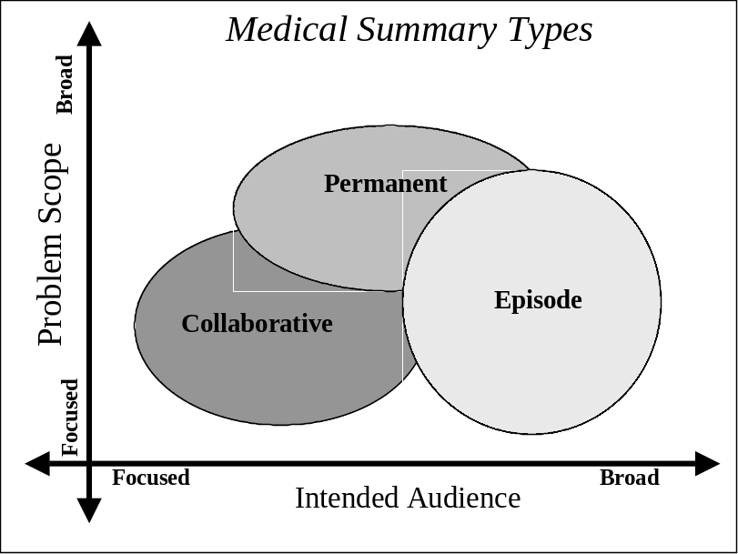Patient transfers, and therefore the summary documents that accompany these transfers can be categorized into 3 primary types: Episodic, Collaborative, or Permanent. These categories are important because they represent a breadth of use case scenarios for Medical Summaries. For example, summaries for collaborative transfers of care such as referral notes have a focused objective for providing the most relevant information about the patient intended for a specific provider. Collaborative summaries have a general audience that generated as an artifact since they also provide the most relevant spot to obtain information about specific classes of patient problems that the patient has.
By contrast, episodic summaries have the primary purpose of highlighting the most relevant details of focused periods of time in a patient history. Examples include discharge summaries or history and physicals. Episodic summaries are written for a broad audience by intent.
Permanent transfers have yet a 3rd purpose of summarizing the entirety of a patient's medical history and therefore covers more broad range of patient problems. The audience may be focused (as in a transfer to a new provider) or general (as in a discharge from the military).
The challenge is then to identify the clinically relevant documents and data elements that belong to typical “transfer of care” scenarios utilized for the continuum of care. The Cross-Enterprise Sharing of Medical Summary (XDS-MS) Integration Profile defines a minimum set of “record entries” that should be forwarded or made available to subsequent care provider(s) during specific transfer of care scenarios. In addition, this integration profile needs to define the utilization requirements/options for the receiving entity in order to ensure that the “care context” of the sending entity is appropriately maintained following the information transfer.

Related Information for the Reader
For the reader of this volume 1, it is recommended to be familiar or read the following documents:
- Volume 1 of the Cross-Enterprise Document Sharing (XDS) Integration Profile documented in the ITI Infrastructure Technical Framework
(See http://www.ihe.net/Technical_Framework/index.cfm ).
- Volume 1 of the Notification of Document Availability (NAV) Integration Profile documented in the ITI Infrastructure Technical Framework
(See http://www.ihe.net/Technical_Framework/index.cfm ).
- HL7 Clinical Document Architecture Release 2: Section 1, CDA Overview.
- Care Record Summary – Implementation Guide for CDA Release 2 (US Realm): Section 1
- Presentations from IHE Workshop: Effective Integration of the Enterprise and the Health System - June 28–29, 2005: http://www.ihe.net/Participation/workshop_2005.cfm, June 2005:
- Leveraging IHE to Build RHIO Interoperability
- Cross-Enterprise Document Sharing (XDS)
- Notification of Document Availability (NAV)
- Patient Care Coordination
- Use Cases for Medical Summaries
- Patient Care Coordination - Overview of Profiles
For the reader of Volume 2 of the IHE Patient Care Coordination Framework, it is recommended to be familiar or read the following documents:
- Volume 2 of the Cross-Enterprise Document Sharing (XDS) Integration Profile documented in the ITI Infrastructure Technical Framework
(See http://www.ihe.net/Technical_Framework/index.cfm ).
- Volume 2 of the Notification of Document Availability (NAV) Integration Profile documented in the ITI Infrastructure Technical Framework
(See http://www.ihe.net/Technical_Framework/index.cfm ).
For the reader of Volume 3, it is recommended to be familiar or read the following documents:
- HL7 Clinical Document Architecture Release 2: Section 1, CDA Overview.
- Care Record Summary – Implementation Guide for CDA Release 2 (US Realm).

Actors/Transactions
Figure 3.1-1 shows the actors directly involved in the Cross-Enterprise Sharing of Medical Summaries Integration Profile and the relevant transactions between them. Other actors that may be indirectly involved due to their participation in Audit trail and Node Authentication and Consistent Time are not shown.
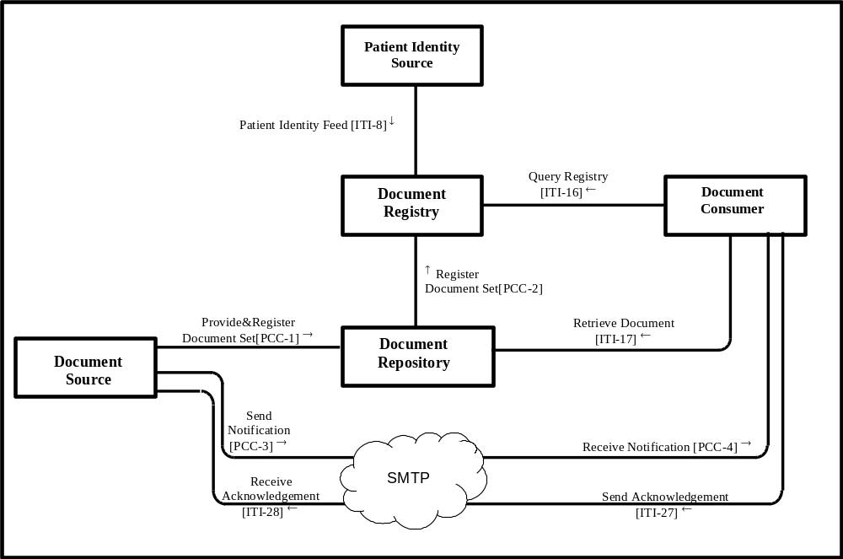
Figure 3.1-1 Cross-Enterprise Sharing of Medical Summaries Diagram

Table 3.1-1 XDS - Actors and Transactions
Actors | Transactions | Optionality | Section in Vol. 2
Document Consumer | Query Registry | R | ITI TF-2: 3.16
Document Consumer | Retrieve Document | R | PCC TF-2: 4.3
Document Source | Provide and Register Document Set | R (Note 1) | PCC TF-2: 4.1
Document Repository | Provide and Register Document Set | R (Note 1) | PCC TF-2: 4.1
Document Repository | Register Document Set | R (Note 2) | PCC TF-2: 4.2
Document Repository | Retrieve Document | R | PCC TF-2: 4.3
Document Registry | Register Document Set | R (Note 2) | PCC TF-2: 4.2
Document Registry | Query Registry | R | ITI TF-2: 3.16
Document Registry | Patient Identity Feed | R | ITI TF-2: 3.8
Patient Identity Source | Patient Identity Feed | R | ITI TF-2: 3.8
Note 1: The Provide and Register Document Set is not required in implementations where the Document Source is grouped with the Document Repository Actor.
Note 2: The Register Document Set Transaction is not required in implementations where the Document Registry Actor is grouped with the Document Repository Actor. However, it is strongly recommended that these transactions be supported to allow for future configuration with multiple Repositories.

Actors

Document Source Actor
The Document Source Actor is the producer and publisher of documents. It is responsible for sending documents to a Document Repository Actor. It also supplies metadata to the Document Repository Actor for subsequent registration of the documents with the Document Registry Actor and may notify of document availability.

Document Consumer Actor
The Document Consumer Actor queries a Document Registry Actor for documents meeting certain criteria, and retrieves selected documents from one or more Document Repository actors. It may be notified of document availability.

Document Registry Actor
The Document Registry Actor maintains metadata about each registered document in a document entry. This includes a link to the Document in the Repository where it is stored. The Document Registry responds to queries from Document Consumer actors about documents meeting specific criteria. It also enforces some healthcare specific technical policies at the time of document registration.

Document Repository Actor
The Document Repository is responsible for both the persistent storage of these documents as well as for their registration with the appropriate Document Registry. It assigns a URI to documents for subsequent retrieval by a Document Consumer.

Patient Identity Source Actor
The Patient Identity Source Actor is a provider of unique identifier for each patient and maintains a collection of identity traits. The Patient Identify Source facilitates the validation of patient identifiers by the Registry Actor in its interactions with other actors.

Transactions

Provide and Register Document Set
A Document Source Actor initiates the Provide and Register Document Set Transaction. For each document in the submitted set, the Document Source Actor provides both the documents as an opaque octet stream and the corresponding metadata to the Document Repository. The Document Repository is responsible to persistently store these documents, and to register them in the Document Registry using the Register Documents transaction by forwarding the document metadata received from the Document Source Actor.

Register
A Document Repository Actor initiates the Register Document Set transaction. This transaction allows a Document Repository Actor to register one or more documents with a Document Registry, by supplying metadata about each document to be registered. This document metadata will be used to create an XDS Document Entry in the registry. The Document Registry Actor ensures that document metadata is valid before allowing documents to be registered. If one or more documents fail the metadata validation, the Register Document Set transaction fails as a whole.

Query Registry
The Document Consumer Actor issues the Query Registry transaction to a Document Registry. The Document Registry Actor searches the registry to locate documents that meet the provider’s specified query criteria. It will return a list of document entries that contain metadata found to meet the specified criteria including

Retrieve Document
A Document Consumer Actor initiates the Retrieve Document transaction. The Document Repository will return the document that was specified by the Document Consumer.

Patient Identity Feed
It conveys the patient identifier and corroborating demographic data, captured when a patient’s identity is established, modified or merged or in cases where the key corroborating demographic data has been modified. Its purpose in the XDS Integration Profile is to populate the registry with patient identifiers that have been registered for the affinity domain.

XDS-MS Integration Profile Options
Options that may be selected for this Integration Profile are listed in the table X.2-1 along with the Actors to which they apply. Dependencies between options when applicable are specified in notes.
Table X.4-1 Actors and Options
Actor | Options | Vol & Section
Document Source | Discharge Summary Option(1)  Referral Option (1) | PCC TF-1: 3.4.1  PCC TF-1: 3.4.2
Document Consumer | View Option (2)  Document Import Option(2)  Section Import Option (2)  Discrete Data Import Option (2) | PCC TF-1: 3.4.3  PCC TF-1: 3.4.4  PCC TF-1: 3.4.5  PCC TF-1: 3.4.6
Document Registry | No Options | -
Document Repository | No Options | -
Patient Identity Feed | No Options | -
Note 1: The Document Source shall support either one or both of these options.
Note 2: The Document Consumer shall support at least one of these options.

Discharge Summary Option
The Document Source that supports the Discharge Summary Option shall be able to support the Provide and Register Document Set Transaction (PCC TF-2: 3.1) or Register Document Set Transaction PCC-2 in a manner that meets the requirements sets by Medical Summary Content Profile (See PCC TF-3) for discharge Summary content.
Note: All discharge summaries shall be structured and coded as required by the Medical Summary Content Profile. The inclusion of the specific coded attributes explicitly defined as optional, may be supported by specific implementations of Document Sources using an IHE identified coded terminology (See PCC TF-3: Appendix A) of their choice. The requirements and manner in which implementations support such capabilities is beyond the scope of this Integration Profile.

Referral Option
The Document Source that supports the Referral Option shall be able to support the Provide and Register Document Set Transaction (PCC TF-2: 3.1) or Register Document Set Transaction PCC-2 in a manner that meets the requirements sets by Medical Summary Content Profile (See PCC TF-3) for referral content.
Note: All referral summaries shall be structured and coded as required by the Medical Summary Content Profile. The inclusion of the specific coded attributes explicitly defined as optional, may be supported by specific implementations of Document Sources using an IHE identified coded terminology (See PCC TF-3: Appendix A) of their choice. The requirements and manner in which implementations support such capabilities is beyond the scope of this Integration Profile.

View Option
The Document Consumer that supports the View Option shall be able to support the Query of Document Metadata necessary by the Document Consumer for its proper Document rendering (Mime type, format code) as well as the Retrieve Document Transaction (PCC TF-2: 3.1) in a manner that supports the rendering of the entire document content, both for discharge summary or referral. This rendering shall meet the requirements defined for CDA Release 2 content presentation semantics (See Section 1.2.4, Human readability and rendering CDA Documents). CDA Header information providing context critical information shall also be rendered in a human readable manner. If a style sheet is attached to the document, it is strongly recommended to offer a means to apply it.
A document after viewing may be discarded by the Document Consumer.
The Document Consumer may allow the provider to print paper copies of any viewable document.
When a viewed Document contains a link to another document, the Document Consumer supporting the View Option shall offer to its users the transparent use of the link information to identify the related document.

Document Import Option
This Option requires that the View Option be supported. In addition, the Document Consumer that supports the Document Import Option shall be able to support the storage of the entire document (integral byte stream as provided by the XDS Repository along with sufficient metadata to ensure its later viewing) both for discharge summary or referral. This Option requires that the user be offered the possibility to consider the document part of the local patient record with the proper tracking of its origin. Once a document has been imported, the Document Consumer shall offer shall offer a means to view the document without the need to query the Document Registry or retrieve it again from the Document Repository. When viewed after it was imported, a Document Consumer may chose or not to query the Document Registry to be notified if the related Document viewed has been deprecated, replaced or addended.
Note: A Document Consumer may choose to query the Document Registry about a document previously imported in order to find out if this previously imported document may have been replaced or has received an addendum. This capability is offered to Document Consumers by this Integration Profile, but not required, as the events that may justify such a query are extremely implementation specific.

Section Import Option
This Option requires that the View Option be supported. In addition, the Document Consumer that supports the Section Import Option shall be able to support the storage of one or more sections of the document (along with sufficient metadata to ensure its later viewing) both for discharge summary or referral. This Option requires that the user be offered the possibility to select specific section(s) to import as part of the local patient record with the proper tracking of its origin. Once sections have been selected and imported, a Document Consumer, shall offer shall offer a means to view the imported section(s) without the need to query the Document Registry or retrieve it again from the Document Repository. When viewed after it was imported, a Document Consumer may chose or not to query the Document Registry to notify the user if the Document related to the Section viewed has been deprecated, replaced or addended.
Note: A Document Consumer may choose to query the Document Registry about a document whose sections were previously imported in order to find out if this previously imported document may have been replaced or has received an addendum. This capability is offered to Document Consumers by this Integration Profile, but not required, as the events that may justify such a query are extremely implementation specific.
This Option does not require, but does not exclude the Document Consumer from offering a means to select and import specific subsets of the narrative text of a section.

Discrete Data Import Option
This Option does not require that the View, Import Document or Section Import Options be supported. The Document Consumer that supports the Discrete Data Import Option shall be able to support the storage of the structured content of one or more sections of the document. This Option requires that the user be offered the possibility to select among the specific sections that include structured content a set of clinically relevant record entries (e.g. a problem or an allergy in a list) for import as part of the local patient record with the proper tracking of its origin.
Note: This note discusses an example of an implementation in an EMR supporting these options. The EMR implements a Document Consumer Actor for this XDS-MS Integration Profile that retrieves medical summary documents and allows the EMR user to use a number of import choices. One of them could be to save the retrieved document to the EMR system. This would be the support of the Document Import Option (See Section 3.6.4). If this implementation supports in addition the “Discrete Data Import” Option, the user may be offered the ability (implicitly or not) to have the document parsed for allergy, problem, and medication lists and all such structured entries found in the imported document are placed in quarantine for review by healthcare providers. A provider reviewing these quarantined items may decide to add some of them as discrete data items to the patient’s local EMR record.
Note: This Discrete Data Import Option does not require the support of the View, Import Document or Import Sections Options so that it could be used alone to support implementations of Document Consumers other than EHRs, such as Public Health Data or Clinical Research systems that would want to aggregate and anonimize specific population healthcare information data as Document Consumer Actors, but one which no care provider actually views the medical summaries. It is expected that most EHR supporting the Discrete Data Import Option would select also one of the of the View, Import Document or Import Sections Options.
When discrete data is accessed after it was imported, a Document Consumer may chose or not to query the Document Registry to notified the user if the Document related to the discrete data viewed has been deprecated, replaced or addended.
Note: A Document Consumer may choose to query the Document Registry about a document from which so discrete data was previously imported in order to find out if this previously imported document may have been replaced or has received an addendum. This capability is offered to Document Consumers by this Integration Profile, but not required, as the events that may justify such a query are extremely implementation specific.

Coded Terminologies extensions
The Medical Summary Content Profile (See PCC TF Volume 3) supports the optional capability to encode a number of coded record entries beyond the IHE required coding associated with structured text. The export and import of these specific coded record entries (See PCC TF-3: Appendix A) is not an explicitly identified option in this XDS-MS Integration Profile, as the associated coded terminologies are not specified by this Integration Profile. Implementations of Document Source and Document Consumers may choose to extend the IHE identified coded terminology used by IHE Medical Summaries (See PCC TF-3, XXX for code terminologies extensions requirements), but interoperability at this level require a agreement between the communicating parties that is beyond the scope of this Integration Profile. With further progress in the development of standard coded terminologies, future extensions to this Integration Profile are expected to address these higher levels of interoperability.

Grouping with Other Profile Actors

Notification of Document Availability (NAV)
A Document Source shall provide the capability to issue a Send Notification Transaction per the Notification of Document Availability (NAV) Integration Profile in order to notify one or more Document Consumer(s) of the availability of one or more documents for retrieval. One of the Acknowledgement Request options may be used to request from a Document Consumer that an acknowledgement should be returned when it has received and processed the notification.
A Document Consumer shall provide the capability to receive a Receive Notification Transaction per the Notification of Document Availability (NAV) Integration Profile in order to be notified by Document Sources of the availability of one or more documents for retrieval. The Send Acknowledgement option may be used to issue a Send Acknowledgement to a Document Source that the notification was received and processed.

Cross Enterprise User Authentication (XUA)
A Document Consumer Actor of the XDS-MS Integration Profile may provide positive identification of the user on behalf of which it is acting in order to support access control decision-making by the XDS Registry and Repositories. To do so, it must be grouped with an X-Service User Actor of the Cross-Enterprise User Authentication Integration Profile.

Document Digital Signature (DSG)
When a Document Source Actor of the XDS-MS Integration Profile needs to digitally sign a medical summary or any other documents in a submission set, it may support the Digital Signature Content Profile as a Document Source. The digital signature(s) documents are registered with the XDS Registry that associates it with the signed document.
When a Document Consumer Actor of the XDS-MS Integration Profile needs to verify a Digital Signature, it may query and retrieve the digital signature document and may perform the verification against the signed document content.

XDS-MS Integration Profile Process Flow
The basic process flow supported by XDS-MS mirrors current manual practices: someone gather the appropriate documents from the patient medical record, copy them, package them up with a cover letter explaining the reason the information is being sent, and then ship the package to the receiving provider. This is often accompanied by a telephone call from the sending provider to the receiving provider that indicates that such information is forthcoming. In cases of unplanned care, it is generally difficult to find out from where to request information about the patient.
It is expected that the transfers of care will occur in an environment where the physician offices and hospitals are coordinated within a regional health information organization that serve the information sharing needs of a community of care settings. A registry/repository-based infrastructure supported by the IHE Cross-Enterprise Document Sharing and other IHE Integration Profiles such as patient identification (PIX & PDQ), security and privacy (CT, ATNA, XUA), and notification of availability of documents (NAV) is used (See IHE IT Infrastructure Technical Framework, http://www.ihe.net/Technical_Framework/index.cfm ). Such an infrastructure will be assumed in the following use cases that will focus on the context for defining the specific clinical information content for Medical Summaries.
Because the Collaborative care transfers and Episodic Care transfers differ significantly, two use cases are defined. Users or implementers of this Integration Profile are offered Options (See PCC TF-1: 3.6) in the support of these use cases.

Use Case 1: Ambulatory Specialist Referral
This use case involves a “collaborative” transfer of care for the referral of a patient from a primary care provider (PCP) to a specialist. This use case is a central component of an “e-referral” process, which typically requires an appropriate level of agreement/collaboration between the two parties prior to the actual transfer of clinical information being initiated.
The preconditions assume a PCP seeing a patient in his office. The PCP has talked to the patient and performed an examination, and has decided to refer the patient to a specialist. An assumption is made that the PCP has an EMR system with capability to write notes and manage data elements. The specific data elements managed by the PCP’s EMR are expected to be the source for the information used in creating the medical summary document related to this transfer of care. A variety of EMR implementations and usage by clinicians may result in some variability in the content of the medical summary.
The detailed content of the medical summary to support this use case will be detailed as part of the document content profile specification (See Volume 3, Section 1 for the Medical Summary Content Profile – US Realm).
Steps to identify the specialist, and obtain insurance preauthorization have been placed out of scope for this Integration Profile.
Post conditions included the specialist physician receiving the notification of referral, locating the documents (via the Document Registry), retrieving the Documents and viewing them and optionally importing data. Import assumes the specialist with an EMR system with the capability for managing those discrete data elements.
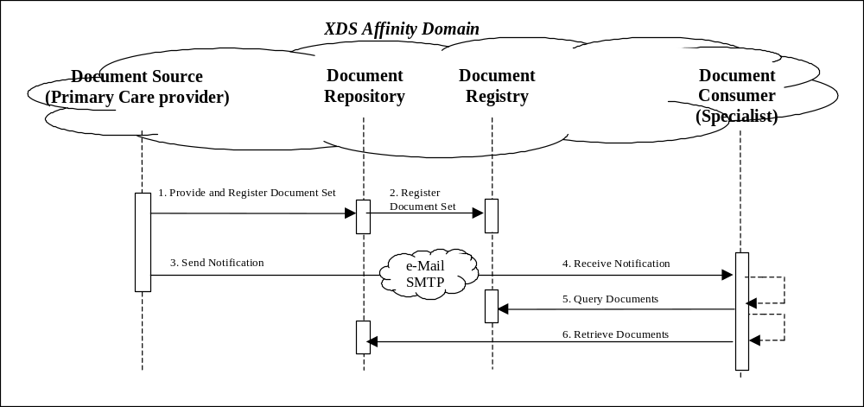
Figure 3.8-1 Use Case 1: Ambulatory Specialist Referral
These steps are:
- Extract/capture a collection of records into a set of documents packaged as an XDS Submission Set. This submission contains a Medical Summary, and may contain a number of other related clinical documents. The various types of medical summaries are a clinical document (already known in the paper world), which serve the dual purpose of documenting an encounter, and providing the rationale for sending the information to another provider. This step utilizes the transactions provided by the ITI XDS profile to place the records in an XDS Repository (local or shared).
- The Repository ensures that the documents of the submission set are registered with the XDS Registry of the Affinity Domain (set of cooperating care delivery institutions).
- The next step is to notify the other provider that documents are now available for review. This step utilizes the transactions provided by the ITI NAV profile to perform the e-mail notification.
- The e-mail notification that contains no patient identified information is received by the specialist EMR system.
- The receiving provider can then utilize existing query transactions from the XDS profile to find the URL of the Documents.
- Finally, the receiving provider may choose to import relevant information from these records into their own EMR system.

Use Case 2: Acute Care Discharge to Ambulatory Care Environment
This use case involves an episodic transfer of care in the form of a patient discharge from a hospital to home. The attending physician in the hospital generates a discharge summary document that is used by the hospital record keeping and billing abstraction. The attending physician in the hospital may or may not also be serving as the patients ambulatory PCP. If not, a copy of this record is sent to the PCP as well as other specialist providers that will have ambulatory follow-up care.
The preconditions of this use case involve a specialist surgeon seeing a patient in the hospital after an operation. The surgeon is ready to discharge the patient, who will be following up in the surgeon's office as well as with his ambulatory PCP. It is assumed the surgeon has been using the hospitals EMR which has capability for a physician documentation function to construct the Discharge Summary. It is further assumed that this documentation component may call other relevant record entries (for example the list of current medications) needed in the construction of the document in addition to the new free-text narratives needed in order to complete the discharge summary. It is noted that variability in EMR implementations and usage may result in considerable variability in the content of the medical summary.
The events of the use case involve creation of the discharge summary and sending it to the PCP’s office and the surgeon’s office.
The post conditions include the receipt and viewing of the discharge summary with optional import into the ambulatory EMR system.
The detailed content of the medical summary to support this use case will be detailed as part of the document content profile specification (See Volume III, Section 1 for the Medical Summary Content Profile – US Realm).
This use case uses the same set of transactions and differs only by the content of the Medical Summary.
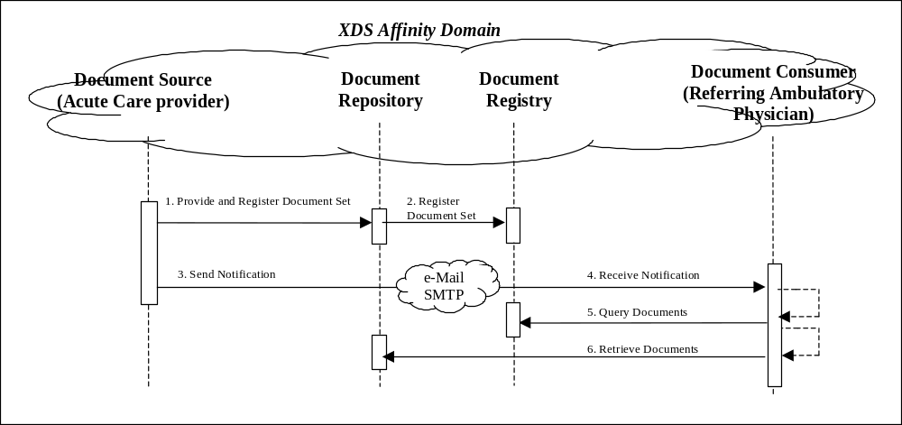
Figure 3.8-2 Use Case 2: Acute Care Discharge to Ambulatory Care Environment

National extensions of Medical Summaries: regional content specialization use case
This Cross-Enterprise Sharing of Medical Summaries Integration Profile is specialized for each regions or countries in term of detailed content of sections and information elements by a set of Document Content Profiles. This Integration profile has been structured to facilitate the inclusion of national extensions in the form of country or “realm” specific Content Profiles. When developed by the national IHE Chapters these will be included in the PCC TF Volume 3.

Use Case for Interoperability Levels
This Cross-Enterprise Sharing of Medical Summaries Integration Profile requires the source of medical summaries as well as the consumer of medical summaries to interoperate by exchanging a fully structured context for the medical summary document (patient demographics, authors, encounter) and a structured human-readable content of the document content so that the document creator and any display consumer would share a generally consistent presentation of the information. The human readable content is structured with coded sections to ensure that sections be easily extracted by computer processing.

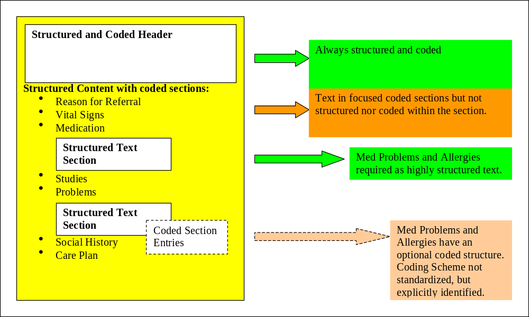
Figure 3.8-3 The three level of interoperability supported – Flexibility and efficiency

In addition to this basic required level that ensures human-to-human communication, selected sections of the document (e.g. problems, medications and allergies in the USA Content Profile) shall support structured textual representation. This structured textual representation allows discrete textual strings to be easily imported.
Note: When a section with a Structured Text definition is used (e.g. medication), each discrete textual strings has a specific meaning (e.g. the dose for a medication), which is computer processable due to the structured information. These discrete textual strings are not duplicate but simply extracts from the human readable text content, reducing the risk for inconsistencies.
This set of selected sections with structured textual representations may be further extended by coded structures that provide a means to encode discrete record entries of information through data structures that are computer processable. If any coded terminology is used it shall be uniquely identified (See PCC TF-3: XXX).

Use Case for unplanned access to past Medical Summaries
This use case involves a precondition where a patient has received care from several providers that have created and share a number of Medical Summaries in the past. In case of an emergency, any provider may need to assess the patient care history. Reviewing one or more Medical Summaries, as well as other documents such as laboratory and radiology reports is a critical means for emergency physicians and nurses to provide the best care to patient in these acute conditions.
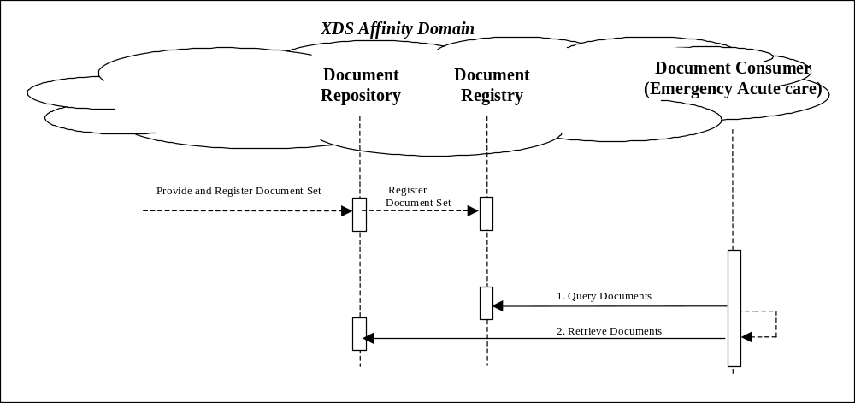
Figure 3.8-4 Unplanned Use Case: Acute Care Emergency

Use Case Conclusion
The process flow of this profile exhibits a great deal more power and flexibility than the existing manual process. The physician workflow is improved by reusing an existing work product in the very first step (the summary report) to accomplish two purposes: recording care that has been provided, and communicating with another provider.
Secondly, each step utilizes the power of inter-connected EMR systems to make the entire process faster, easier, and less reliant on human labor to accomplish the same feats. This results in reduced time to transfer records between providers, safer transport of the information, and more reliable receipt.
Lastly, the process facilitates the import of relevant data from one set of patient records to the receiving physicians EHR system, resulting in more reliable transfer of information, reduced labor costs transferring information from one provider to another and less time required by the patient to provide information that is already in the physician's possession.

Security Considerations
The XDS-MS Integration Profile assumes that a minimum security and privacy environment has been established across all participants. There must exist security policies regarding the use of training, agreements, risk management, business continuity and network security that need to be already in place prior to the implementation of XDS-MS.
The IHE ITI ATNA Integration Profile is required of the actors involved in the XDS transactions specified in this profile to protect node-to-node communication and to produce an audit trail of the PHI related actions when they exchange messages.
In addition, IHE ITI XUA and DGS Integration Profiles can be applied to the actors involved in the transactions specified in this profile to securely identify individuals involved in transactions (XUA) and verify document integrity and authorizations (DGS).
Interested parties should also read the detailed Security Considerations sections provided for each of the aforementioned profiles in the IHE ITI Technical Framework and its supplements.
The XDS-MS profile does have a few security considerations of its own.
EHR systems should be thoughtfully designed so that providers are able to review and verify information before it is imported into their EHR system, and that positive acknowledgements are made before import, and audit trails are recorded when imports occur.
Imported information should be traceable both to the source [the sharing EHR], and the receiver that accepted it into the EHR system. XDS Affinity domain policies should support policies and procedures for tracing information flows between EHR systems.
Because the information being transferred is in XML, it will be common that different EHR systems utilize different transformations to render the contents into human readable form. A Document Source must make available the transforms used by the sending provider to review the documents, and a Document Consumer must support rendering the information as seen by the sending provider, allowing both providers to see what was sent in its original rendered form.
- Actor Descriptions
Actors are information systems or components of information systems that produce, manage, or act on information associated with operational activities in the enterprise. The following are definitions of actors used in the IHE Patient Care Coordination Integration Profiles:

Document Source - The Document Source Actor is the producer and publisher of documents. It is responsible for sending documents to a Document Repository Actor. It also supplies metadata to the Document Repository Actor for subsequent registration of the documents with the Document Registry Actor.
Document Consumer - The Document Consumer Actor queries a Document Registry Actor for documents meeting certain criteria, and retrieves selected documents from one or more Document Repository actors.
Document Registry - The Document Registry Actor maintains metadata about each registered document in a document entry. This includes a link to the Document in the Repository where it is stored. The Document Registry responds to queries from Document Consumer actors about documents meeting specific criteria. It also enforces some healthcare specific technical policies at the time of document registration.
Document Repository - The Document Repository is responsible for both the persistent storage of these documents as well as for their registration with the appropriate Document Registry. It assigns a URI to documents for subsequent retrieval by a Document Consumer.
Patient Identity Source - The Patient Identity Source Actor is a provider of unique identifier for each patient and maintains a collection of identity traits. The Patient Identify Source facilitates the validation of patient identifiers by the Registry Actor in its interactions with other actors.
Time Client – Establishes time synchronization with one or more Time Servers using the NTP protocol and either the NTP or SNTP algorithms. Maintains the local computer system clock synchronization with UTC based on synchronization with the Time Servers.
- Transaction Descriptions
Transactions are interactions between actors that transfer the required information through standards-based messages. The following are brief descriptions of the transactions defined by IHE.
Provide and Register Document Set - A Document Source Actor initiates the Provide and Register Document Set Transaction. For each document in the submitted set, the Document Source Actor provides both the documents as an opaque octet stream and the corresponding metadata to the Document Repository. The Document Repository is responsible to persistently store these documents, and to register them in the Document Registry using the Register Documents transaction by forwarding the document metadata received from the Document Source Actor.
Register Document Set - A Document Repository Actor initiates the Register Document Set transaction. This transaction allows a Document Repository Actor to register one or more documents with a Document Registry, by supplying metadata about each document to be registered. This document metadata will be used to create an XDS Document Entry in the registry. The Document Registry Actor ensures that document metadata is valid before allowing documents to be registered. If one or more documents fail the metadata validation, the Register Document Set transaction fails as a whole.
Query Registry - The Document Consumer Actor issues the Query Registry transaction to a Document Registry. The Document Registry Actor searches the registry to locate documents that meet the provider’s specified query criteria. It will return a list of document entries that contain metadata found to meet the specified criteria including the locations and identifier of each corresponding document in one or more Document Repositories.
Retrieve Document - A Document Consumer Actor initiates the Retrieve Document transaction. The Document Repository will return the document that was specified by the Document Consumer.
Patient Identity Feed - It conveys the patient identifier and corroborating demographic data, captured when a patient’s identity is established, modified or merged or in cases where the key corroborating demographic data has been modified. Its purpose in the XDS Integration Profile is to populate the registry with patient identifiers that have been registered for the affinity domain.
- IHE Integration Statements
IHE Integration Statements are documents prepared and published by vendors to describe the conformance of their products with the IHE Technical Framework. They identify the specific IHE capabilities a given product supports in terms of IHE actors and integration profiles (described in ITI TF-1: 2).
Users familiar with these concepts can use Integration Statements to determine what level of integration a vendor asserts a product supports with complementary systems and what clinical and operational benefits such integration might provide. Integration Statements are intended to be used in conjunction with statements of conformance to specific standards (e.g. HL7, IETF, DICOM, W3C, etc.).
IHE provides a process for vendors to test their implementations of IHE actors and integration profiles. The IHE testing process, culminating in a multi-party interactive testing event called the Connect-a-thon, provides vendors with valuable feedback and provides a baseline indication of the conformance of their implementations. The process is not intended to independently evaluate, or ensure, product compliance. In publishing the results of the Connect-a-thon and facilitating access to vendors’ IHE Integration Statements, IHE and its sponsoring organizations are in no way attesting to the accuracy or validity of any vendor’s IHE Integration Statements or any other claims by vendors regarding their products.
IMPORTANT -- PLEASE NOTE: Vendors have sole responsibility for the accuracy and validity of their IHE Integration Statements. Vendors’ Integration Statements are made available through IHE simply for consideration by parties seeking information about the integration capabilities of particular products. IHE and its sponsoring organizations have not evaluated or approved any IHE Integration Statement or any related product, and IHE and its sponsoring organizations shall have no liability or responsibility to any party for any claims or damages, whether direct, indirect, incidental or consequential, including but not limited to business interruption and loss of revenue, arising from any use of, or reliance upon, any IHE Integration Statement.
Structure and Content of an IHE Integration Statement
An IHE Integration Statement for a product shall include:
- The Vendor Name
- The Product Name (as used in the commercial context) to which the IHE Integration Statement applies.
- The Product Version to which the IHE Integration Statement applies.
- A publication date and optionally a revision designation for the IHE Integration Statement.
- The following statement: “This product implements all transactions required in the IHE Technical Framework to support the IHE Integration Profiles, Actors and Options listed below:”
- A list of IHE Integration Profiles supported by the product and, for each Integration Profile, a list of IHE Actors supported. For each integration profile/actor combination, one or more of the options defined in the IHE Technical Framework may also be stated. Profiles, Actors and Options shall use the names defined by the IHE Technical Framework Volume I. (Note: The vendor may also elect to indicate the version number of the Technical Framework referenced for each Integration Profile.)
Note that implementation of the integration profile implies implementation of all required transactions for an actor as well as selected options.
The statement shall also include references and/or internet links to the following information:
- Specific internet address (or universal resource locator [URL]) where the vendor’s Integration Statements are posted
- URL where the vendor’s standards conformance statements (e.g., HL7, DICOM, etc.) relevant to the IHE transactions implemented by the product are posted.
- URL of the IHE Initiative’s web page for general IHE information www.himss.org/ihe.
An IHE Integration Statement is not intended to promote or advertise aspects of a product not directly related to its implementation of IHE capabilities.
Format of an IHE Integration Statement
Each Integration Statement shall follow the format shown below. Vendors may add a cover page and any necessary additional information in accordance with their product documentation policies.

IHE Integration Statement |  |  |  |  |  | Date |  | 12 Oct 2005
Vendor |  | Product Name |  |  |  | Version
Any Medical Systems Co. |  | IntegrateRecord |  |  |  | V2.3
This product implements all transactions required in the IHE Technical Framework to support the IHE Integration Profiles, Actors and Options listed below:
Integration Profiles Implemented |  |  |  | Actors Implemented |  |  | Options Implemented
Retrieve Information for Display |  |  |  | Information Source |  |  | none
Enterprise User Authentication |  |  |  | Kerberized Server |  |  | none
Patient Identity Cross-referencing |  |  |  | Patient Identifier Cross-reference Consumer |  |  | PIX Update Notification
Internet address for vendor’s IHE information: www.anymedicalsystemsco.com/ihe
Links to Standards Conformance Statements for the Implementation
HL7 | www.anymedicalsystemsco.com/hl7
Links to general information on IHE
In North America: www.ihe.het |  |  | In Europe: www.ihe-europe.org |  | In Japan: www.jira-net.or.jp/ihe-j

GLOSSARY

Actor: An entity within a use case diagram that can perform an action within a use case diagram. Possible actions are creation or consumption of a message
ADT: Admit, Discharge & Transfer.
Care Context: The participations surrounding the care provision act, and the attributes of that act. Everything in the document header. Data history, links to clinical reasoning.
CDA: Clinical Document Architecture (specified by HL7).
CT: Consistent Time Integration Profile.
eMPI: Enterprise Master Patient Index.
EMR: Electronic Medical Record, an Electronic Health Record system used within an enterprise to deliver care (also called EHR-CR by IHE-XDS).
EUA: Enterprise User Authentication Integration Profile.
Expected Actions: Actions which should occur as the result of a trigger event.
HIMSS: Healthcare Information and Management Systems Society.
HIS: Hospital Information System.
IHE: Integrating the Healthcare Enterprise.
Interaction Diagram: A diagram that depicts data flow and sequencing of events.
IT: Information Technology.
MPI: Master Patient Index.
MRN: Medicare Record Number.
OID: Object Identifier. (See also 'Globally Unique Identifier’).
Patient Identifier Cross-reference Domain: Consists of a set of Patient Identifier Domains known and managed by a Patient Identifier Cross-reference Manager Actor. The Patient Identifier Cross-reference Manager Actor is responsible for providing lists of “alias” identifiers from different Patient Identifier Domains.
Patient Identifier Domain: A single system or a set of interconnected systems that all share a common identification scheme for patients. Such a scheme includes: (1) a single identifier-issuing authority, (2) an assignment process of an identifier to a patient, (3) a permanent record of issued patient identifiers with associated traits, and (4) a maintenance process over time. The goal of Patient Identification is to reduce errors.
PDF: Portable Document Format.
Process Flow Diagram: A graphical illustration of the flow of processes and interactions among the actors involved in a particular example.
Role: The actions of an actor in a use case.
RSNA: Radiological Society of North America.
sig.: A Latin abbreviation for signetur used to represent the instruction following the medication name.
Scope: A brief description of the transaction.
Trigger Event: An event such as the reception of a message or completion of a process, which causes another action to occur.
UID: Unique Identifier (See also Globally Unique Identifier).
Universal ID: Unique identifier over time within the UID type. Each UID must belong to one of specifically enumerated species. Universal ID must follow syntactic rules of its scheme.
Use Case: A graphical depiction of the actors and operation of a system.

ACC, HIMSS and RSNA
Integrating the Healthcare Enterprise

IHE Patient Care Coordination
Technical Framework
Volume 2 - Transactions

2005-2006

Public Comment Draft July 22, 2005
Comments due August 22, 2005

Introduction
Integrating the Healthcare Enterprise (IHE) is an initiative designed to stimulate the integration of the information systems that support modern healthcare institutions. Its fundamental objective is to ensure that in the care of patients all required information for medical decisions is both correct and available to healthcare professionals. The American College of cardiology (ACC), the Healthcare Information and Management Systems Society (HIMSS), the Radiological Society of North America (RSNA) are the current sponsors of this initiative. Other organizations representing healthcare professionals are invited to join with them.
The IHE initiative is both a process and a forum for encouraging integration efforts. It defines a technical framework for the implementation of established information exchange standards to achieve specific clinical goals. It includes a rigorous testing process for the implementation of this framework. And it organizes educational sessions and exhibits at major meetings of medical professionals to demonstrate the benefits of this framework and encourage its adoption by industry and users.
The approach employed in the IHE initiative is not to define new integration standards, but rather to support the use of existing standards⎯ HL7, IETF, ASTM, DICOM, ISO, OASIS, and potentially others, as appropriate in their respective domains⎯in an integrated manner, defining configuration choices when necessary. When clarifications or extensions to existing standards are necessary, IHE refers recommendations to the relevant standards bodies.

Overview of Technical Framework
This document, part of the IHE Technical Framework, defines specific implementations of established standards to achieve integration goals that promote appropriate sharing of medical information to support optimal patient care. It is expanded annually, after a period of public review, and maintained regularly through the identification and correction of errata. The latest version of the document is always available via the Internet at www.ihe.net.
The IHE Technical Framework defines a subset of the functional components of the healthcare enterprise, called IHE Actors, and specifies their interactions in terms of a set of coordinated, standards-based transactions. It defines this body of transactions in progressively greater depth. Volume I provides a high-level view of IHE functionality, showing the transactions organized into functional units called Integration Profiles that highlight their capacity to address specific clinical needs.

Overview of Volume 2
Section 2 presents the conventions used in this volume to define the transactions implemented under IHE.
Section 3 provides an overview of the concepts of IHE actors and transactions used in IHE to define the functional components of a distributed healthcare environment.
Section 4 defines transactions in detail, specifying the roles for each actor, the standards employed, the information exchanged, and in some cases, implementation options for the transaction.
The appendices following the main body of this volume provide clarification of technical details of the IHE data model and transactions. The final section of the volume is a glossary of terms and acronyms used in the IHE Technical Framework, including those from relevant standards.

Audience
The intended audience of this document is:
- Technical staff of vendors planning to participate in the IHE initiative
- IT departments of healthcare institutions
- Experts involved in standards development
- Anyone interested in the technical aspects of integrating healthcare information systems

Relationship to Standards
The IHE Technical Framework identifies functional components of a distributed healthcare environment solely from the point of view of their interactions in the healthcare enterprise. At its current level of development, it defines a coordinated set of transactions based on an expanding number of standards.
In some cases, IHE recommends selection of specific options supported by these standards; however, IHE does not introduce technical choices that contradict conformance to these standards. If errors in or extensions to existing standards are identified, IHE’s policy is to submit those to the appropriate standards bodies for resolution within their conformance and standards evolution strategy. IHE is therefore an implementation framework, not a standard. Referencing IHE as a standard and claiming conformance to IHE are both inappropriate. Conformance claims must be made in direct reference to specific standards. Conformance statements may, however, state that the products they describe are “implemented in accordance with the IHE Technical Framework”. See PCC TF-1, Appendix C for the suggested form of such statements.
IHE encourages implementers to ensure that products implemented in accordance with the IHE Technical Framework also meet the full requirements of the standards underlying IHE, allowing the products to interact, although possibly at a lower level of integration, with products that have been implemented in compliance with the standards but that may not meet the IHE requirements.

Relationship to Real-world Architectures
The actors and transactions described in the IHE Technical Framework are abstractions of the real-world healthcare information system environment. While some of the transactions are traditionally performed by specific product categories (EMR, Clinical Systems, etc.), the IHE Technical Framework intentionally avoids associating functions or actors with such product categories. For each actor, the IHE Technical Framework defines only those functions associated with integrating information systems. The IHE definition of an actor should therefore not be taken as the complete definition of any product that might implement it, nor should the framework itself be taken as the complete definition of a healthcare information system architecture.
The reason for defining actors and transactions is to provide a basis for defining the interactions among functional components of the healthcare information system environment. In situations where a single physical product implements multiple functions, only the interfaces between the product and external functions in the environment are considered to be significant by the IHE initiative. Therefore, the IHE initiative takes no position on the relative merits of an integrated environment based on a single, all-encompassing information system versus one based on multiple systems that together achieve the same end.

Comments
The IHE sponsors welcome comments on this document and the IHE initiative. They should be directed to the discussion server at http://forums.rsna.org or to:
Joyce Sensmeier
Director of Professional Services
230 East Ohio St., Suite 500
Chicago, IL 60611
Email: ihe@himss.org

Copyright Permission
Health Level Seven, Inc., has granted permission to the IHE to reproduce tables from the HL7 standard. The HL7 tables in this document are copyrighted by Health Level Seven, Inc. All rights reserved.
Material drawn from these documents is credited where used.

Conventions
This document has adopted the following conventions for representing the framework concepts and specifying how the standards upon which the IHE Technical Framework is based should be applied.

The Generic IHE Transaction Model
Transaction descriptions are provided in section 4. In each transaction description, the actors, the roles they play, and the transactions between them are presented as use cases.
The generic IHE transaction description includes the following components:
- Scope: a brief description of the transaction.
- Use case roles: textual definitions of the actors and their roles, with a simple diagram relating them, e.g.:
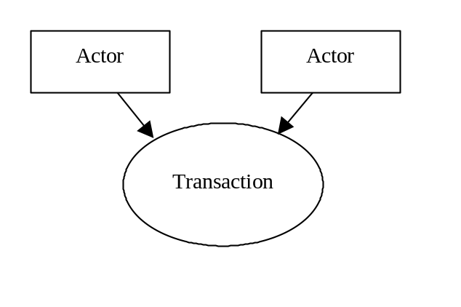
- Referenced Standards: the standards (stating the specific parts, chapters or sections thereof) to be used for the transaction.
- Interaction Diagram: a graphical depiction of the actors and transactions, with related processing within an actor shown as a rectangle and time progressing downward, similar to:
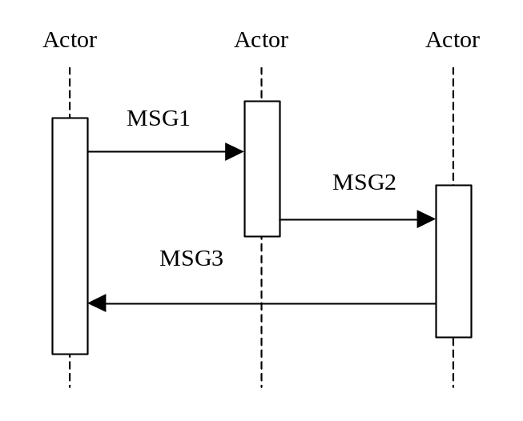
The interaction diagrams used in the IHE Technical Framework are modeled after those described in Grady Booch, James Rumbaugh, and Ivar Jacobson, The Unified Modeling Language User Guide, ISBN 0-201-57168-4. Simple acknowledgment messages are omitted from the diagrams for brevity.
- Message definitions: descriptions of each message involved in the transaction, the events that trigger the message, its semantics, and the actions that the message triggers in the receiver.

Role of this Volume in the Technical Framework
The IHE Technical Framework is based on actors that interact through transactions.
Actors are information systems or components of information systems that produce, manage, or act on information associated with operational activities in the enterprise.
Transactions are interactions between actors that transfer the required information through standards-based messages.
The implementation of the transaction described in this PCC-TF Volume 2 support the specification of Integration Profiles defined in PCC TF-Volume 1. The role and implementation of these transactions require the understanding of the Integration profile they support.

IHE Transactions
This section defines each IHE transaction in detail, specifying the standards used, and the information transferred.

Provide and Register Document Set
This section corresponds to Transaction PCC-1 of the IHE Technical Framework.

Scope
This Transaction is used to send a submission set containing a Medical Summary and related documents from one provider's EHR system to a Document Repository of an XDS Affinity Domain.

Use Case Roles
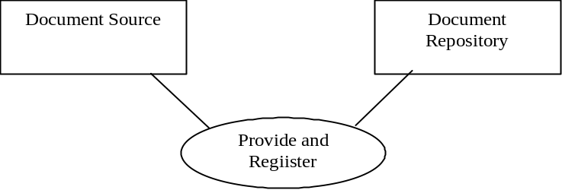
Actor: Document Source
Role: A system that submits documents and associated metadata to a Document Repository.
Actor: Document Repository
Role: A document storage system that receives documents and associated metadata and:
- Stores the documents
- Enhances submitted metadata with repository information to enable later retrieval of documents
Forwards the enhanced metadata to the Document Registry.

Referenced Standards
This transaction builds upon transactions from the IHE ITI Cross Enterprise Document Sharing (XDS), IHE ITI Notification of Document Availability (NAV), and the Medical Summaries Content Profile in Volume 3 of the PCC Technical Framework.

Interaction Diagram

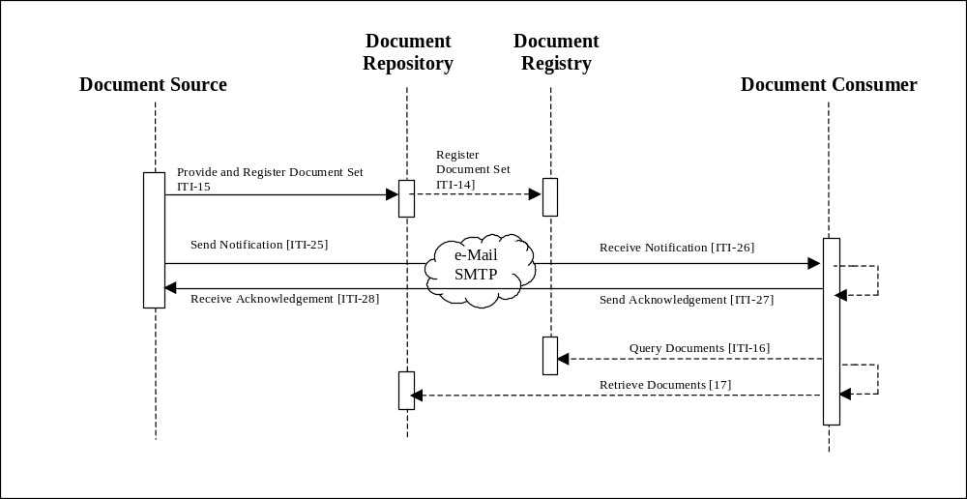

Provide and Register Transaction

Trigger Events
Upon completion of a discharge or transfer summary for an inpatient stay.
Upon completion of a summary of episode with the intention of referral to another provider.

Message Semantics
The Document Source will prepare an XDS Submission Set containing a Medical Summary document as defined by the Medical Summary Content Profile found in Volume 3 of the PCC Technical Framework, and submit that to a repository using Transaction ITI-15 Provide and Register Document Set.
The Document Source should include within this submission set a copy of any document referenced by the Medical Summary so contained, and may include additional documents.
The Document Source shall support the preparation and sending of an ITI XDS-25 Notification of Document Availability message to the Document Source, once the registration has been successful. The mechanism by which the Document Source is identified is left unspecified, but should support provider interaction to select the appropriate destination(s) for the notification(s).
The Document Source may request for an acknowledgement, and if so requested may wait for an Acknowledgement.

Expected Actions
The Document Source will ensure that all documents form the Submission Set are registered, or report an error [to the user or system administrator] if registration cannot be completed.
The Document Source will send a Notification of Document Availability Message to the Document Consumer(s).
The Document Source may wait for an Acknowledgement from the Document Consumer(s), and take appropriate actions if one is not received in an application configurable period of time. Such actions may include resending the Notification Message, reporting the lack of acknowledgement to the originating provider, logging the failure, etc.

Register Document Set
This section corresponds to Transaction PCC-2 of the IHE Technical Framework.

Scope
This Transaction is used to register metadata about a submission set containing a Medical Summary and related documents from one provider's EHR system to a Document Registry of an XDS Affinity Domain.

Use Case Roles
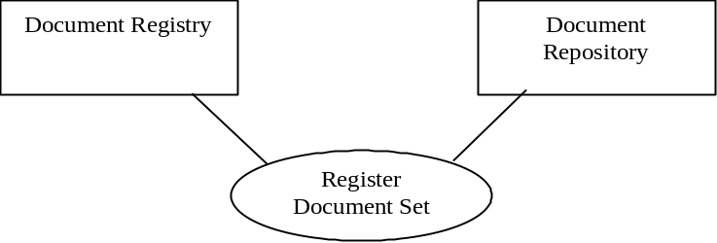
Actor: Document Repository
Role: A document storage system that submits document metadata to a Document Registry.
Actor: Document Registry
Role: A document indexing system that receives and stores document metadata.

Referenced Standards
This transaction builds upon transactions from the IHE ITI Cross Enterprise Document Sharing (XDS), IHE ITI Notification of Document Availability (NAV), and the Medical Summaries Content Profile in Volume 3 of the PCC Technical Framework.

Interaction Diagram

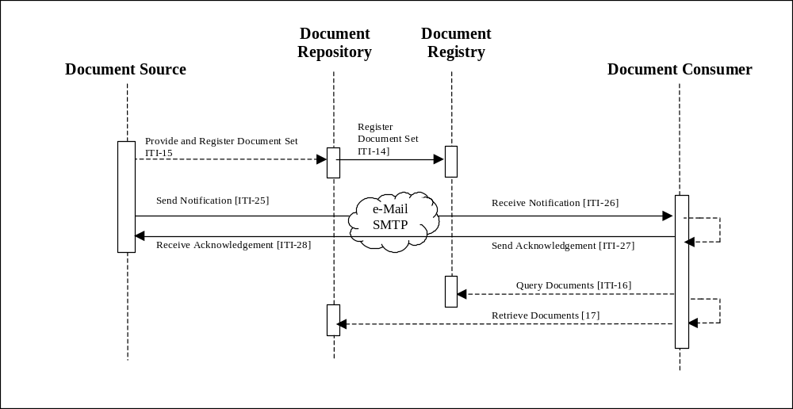

Register Transaction

Trigger Events
Upon receipt of a Provide and Register Transaction.
When a repository is grouped with a Document Source, upon completion of a discharge or transfer summary for an inpatient stay.
When a repository is grouped with a Document Source, upon completion of a summary of episode with the intention of referral to another provider.

Message Semantics
When the Document Source is not grouped with a Document Repository this transaction is identical to ITI-14.
When the Document Source is grouped with a Document repository:
- They shall prepare an XDS Submission Set containing a Medical Summary document as defined by the Medical Summary Content Profile found in Volume 3 of the PCC Technical Framework, and register it to a registry using Transaction ITI-14 Register Document Set.
- The Document Source/Repository should include within this submission set a copy of any document referenced by the Medical Summary so contained, and may include additional documents.
- The Document Source/Repository shall support the preparation and sending of an ITI XDS-25 Notification of Document Availability transaction to the Document Source, once the registration has been successful. The mechanism by which the Document Source is identified is left unspecified, but should support provider interaction to select the appropriate destination(s) for the notification(s).
- The Document Source/Repository may request for an acknowledgement, and if so requested may wait for an Acknowledgement.

Expected Actions
The Document Repository will ensure that all documents form the Submission Set are registered, or report an error [to the user or system administrator] if registration cannot be completed.
The Document Source will send a Notification of Document Availability Message to the Document Consumer(s).
The Document Repository may wait for an Acknowledgement from the Document Consumer(s), and take appropriate actions if one is not received in an application configurable period of time. Such actions may include resending the Notification Message, reporting the lack of acknowledgement to the originating provider, logging the failure, etc.

Retrieve Document
This section corresponds to Transaction PCC-3 of the IHE Technical Framework.

Scope
This Transaction is used by a Document Consumer upon a local user decision to browse the Document registry or when alerted to retrieve and process a Submission Set including a Medical Summary.

Use Case Roles
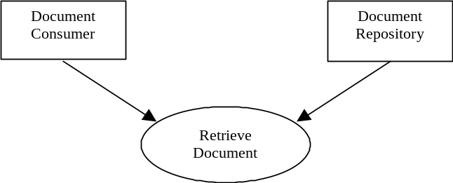
Actor: Document Consumer
Role: Obtains document.
Actor: Document Repository
Role: Provides documents.

Referenced Standards
See IHE ITI Cross Enterprise Document Sharing (XDS), IHE ITI Notification of Document Availability (NAV), and the Medical Summaries Content Profile in Volume III of the PCC Technical Framework.

Interaction Diagram
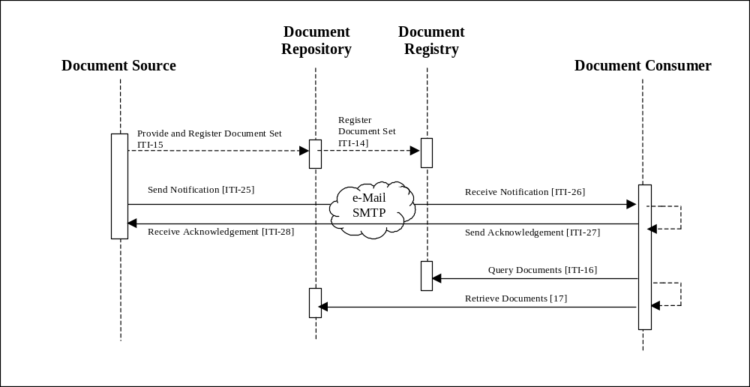

Retrieve Document

Trigger Events
Upon receipt of a notification of document availability message that references a Medical Summary Document.

Message Semantics
If an acknowledgment is requested, the Document Consumer shall initiate an ITI-27 Send Acknowledgment transaction. The Document Consumer shall notify the provider designated in the Notification message of the received package.
The Document Consumer shall query the repository for appropriate metadata using the ITI-16 Query Documents transaction. More than one Medical Summary document may be present in the Submission Set. However, the nature of the Provide and register and Register transactions are such that the most recently created Medical Summary is "the" Medical Summary that drove the creation of the Submission Set. Other Medical Summaries are prior medical Summaries that may not have been published. In general prior Medical Summaries with be submitted by reference.
The Document Consumer shall request the content of the Medical Summary document using the IHE ITI-17 Retrieve Document transaction.
The Document Consumer may request the content of other related documents using IHE ITI-17 Retrieve Document transaction, and may initiate further queries using the IHE ITI-16 transaction.

View Option
When this option is implemented, the requirements defined in PCC TF-1: 3.5.3 shall be met.

Import Document Option
When this option is implemented, the requirements defined in PCC TF-1: 3.5.4 shall be met.

Import Sections Option
When this option is implemented, the requirements defined in PCC TF-1: 3.5.5 shall be met.

Import Discrete Data
When this option is implemented, the requirements defined in PCC TF-1: 3.5.6 shall be met.

ACC, HIMSS and RSNA
Integrating the Healthcare Enterprise

IHE Patient Care Coordination
Technical Framework
Volume 3 – Document Content Profiles

2005-2006

Public Comment Draft July 22, 2005
Comments due August 22, 2005

Introduction
Integrating the Healthcare Enterprise (IHE) is an initiative designed to stimulate the integration of the information systems that support modern healthcare institutions. Its fundamental objective is to ensure that in the care of patients all required information for medical decisions is both correct and available to healthcare professionals. The American College of cardiology (ACC), the Healthcare Information and Management Systems Society (HIMSS), the Radiological Society of North America (RSNA) are the current sponsors of this initiative. Other organizations representing healthcare professionals are invited to join with them.
The IHE initiative is both a process and a forum for encouraging integration efforts. It defines a technical framework for the implementation of established information exchange standards to achieve specific clinical goals. It includes a rigorous testing process for the implementation of this framework. And it organizes educational sessions and exhibits at major meetings of medical professionals to demonstrate the benefits of this framework and encourage its adoption by industry and users.
The approach employed in the IHE initiative is not to define new integration standards, but rather to support the use of existing standards⎯ HL7, IETF, ASTM, DICOM, ISO, OASIS, and potentially others, as appropriate in their respective domains⎯in an integrated manner, defining configuration choices when necessary. When clarifications or extensions to existing standards are necessary, IHE refers recommendations to the relevant standards bodies.

Overview of Technical Framework
This document, part of the IHE Technical Framework, defines specific implementations of established standards to achieve integration goals that promote appropriate sharing of medical information to support optimal patient care. It is expanded annually, after a period of public review, and maintained regularly through the identification and correction of errata. The latest version of the document is always available via the Internet at www.ihe.net.
The IHE Technical Framework defines a subset of the functional components of the healthcare enterprise, called IHE Actors, and specifies their interactions in terms of a set of coordinated, standards-based transactions. It defines this body of transactions in progressively greater depth. Volume I provides a high-level view of IHE functionality, showing the transactions organized into functional units called Integration Profiles that highlight their capacity to address specific clinical needs.

Overview of Volume 3
Section 2 presents the conventions used in this volume to define the document content implemented under IHE.
Section 3 provides an overview of the concepts in this Volume to define the content components of documents shared in a distributed healthcare environment.
Section 4 defines document content profiles in detail, specifying the metadata mappings for managing these documents, the standards employed, the information structures exchanged, and in some cases, implementation options for the content profile.
The appendices following the main body of this volume provide specific specification elements that may be reused as well as clarification of technical details. The final section of the volume is a glossary of terms and acronyms used in the IHE Technical Framework, including those from relevant standards.

Audience
The intended audience of this document is:
- Technical staff of vendors planning to participate in the IHE initiative
- IT departments of healthcare institutions
- Experts involved in standards development
- Anyone interested in the technical aspects of integrating healthcare information systems

Relationship to Standards
The IHE Technical Framework identifies functional components of a distributed healthcare environment solely from the point of view of their interactions in the healthcare enterprise. At its current level of development, it defines a coordinated set of transactions based on an expanding number of standards.
In some cases, IHE recommends selection of specific options supported by these standards; however, IHE does not introduce technical choices that contradict conformance to these standards. If errors in or extensions to existing standards are identified, IHE’s policy is to submit those to the appropriate standards bodies for resolution within their conformance and standards evolution strategy. IHE is therefore an implementation framework, not a standard. Referencing IHE as a standard and claiming conformance to IHE are both inappropriate. Conformance claims must be made in direct reference to specific standards. Conformance statements may, however, state that the products they describe are “implemented in accordance with the IHE Technical Framework”. See PCC TF-1, Appendix C for the suggested form of such statements.
IHE encourages implementers to ensure that products implemented in accordance with the IHE Technical Framework also meet the full requirements of the standards underlying IHE, allowing the products to interact, although possibly at a lower level of integration, with products that have been implemented in compliance with the standards but that may not meet the IHE requirements.

Relationship to Real-world Architectures
The actors, transactions and document content described in the IHE Technical Framework are abstractions of the real-world healthcare information system environment. While some of the transactions are traditionally performed by specific product categories (EMR, Clinical Systems, etc.), the IHE Technical Framework intentionally avoids associating functions or actors with such product categories. For each actor, the IHE Technical Framework defines only those functions associated with integrating information systems. The IHE definition of an actor should therefore not be taken as the complete definition of any product that might implement it, nor should the framework itself be taken as the complete definition of a healthcare information system architecture.
The reason for defining actors, transactions and document content is to provide a basis for defining the interactions among functional components of the healthcare information system environment. In situations where a single physical product implements multiple functions, only the interfaces between the product and external functions in the environment are considered to be significant by the IHE initiative. Therefore, the IHE initiative takes no position on the relative merits of an integrated environment based on a single, all-encompassing information system versus one based on multiple systems that together achieve the same end.

Comments
The IHE sponsors welcome comments on this document and the IHE initiative. They should be directed to the discussion server at http://forums.rsna.org or to:
Joyce Sensmeier
Director of Professional Services
230 East Ohio St., Suite 500
Chicago, IL 60611
Email: ihe@himss.org

Copyright Permission
Health Level Seven, Inc., has granted permission to the IHE to reproduce tables from the HL7 standard. The HL7 tables in this document are copyrighted by Health Level Seven, Inc. All rights reserved.
Material drawn from these documents is credited where used.

Conventions
This document has adopted the following conventions for representing the framework concepts and specifying how the standards upon which the IHE Technical Framework is based should be applied.
Italics
Used for filenames, URL, email addresses or new terms.
Constant Width
Used for code examples
Boldface Constant Width
Used for code examples that should be replaced with specific items.

Role of this Volume in the Technical Framework
The IHE Technical Framework is based on actors that interact through transactions.
Actors are information systems or components of information systems that produce, manage, or act on information associated with operational activities in the enterprise.
Transactions are interactions between actors that transfer the required information through standards-based messages.
The Document Content Profiles specified in this PCC TF-Volume 3 provide the clinical information content for documents that are shared using some of the transactions specified in PCC TF-Volume 2. In turn, implementation of the transaction described in the PCC-TF Volume 2 support the specification of Integration Profiles defined in PCC TF-Volume 1.
The role and implementation of the document content specified in this volume require an understanding of the transactions and the integration profiles they support.

Medical Summary Content Profile – US Realm
This section describes the Medical Summary Content Profile to be used with XDS-MS in the US Realm.

Related Content Profiles
No other IHE Content Profiles have been defined that are related at this time.

Context for Content Profile
The business requirements for clinical document exchange are described fully in PCC TF-1: 3.1. This section focuses on the techniques used to constrain the HL7 CDA Release 2 clinical document specification in order to narrow the document specifications appropriately for use in the Cross-Enterprise Sharing of Medical Summaries Integration Profile.
The Cross-Enterprise Sharing of Medical Summary (XDS-MS) Content Profiles define minimum sets of “medical record entries” for each clinical document type that should be included in the document, depending on the nature of the specific transfer of care scenario. In addition, this integration profile defines the utilization requirements/options for the receiving entity in order to ensure that the “care context” of the sending entity is appropriately maintained following the information transfer. These receiving responsibilities are considered important for safe patient care following transfer, and patient safety issues drive many implementation decisions in the Content Profiles presented in this Volume.
This content specification is build on basic research and practices in electronic medical records, including, specifically, the problem-oriented medical record descriptions that dates back to the 1960’s. In addition, this work builds on CDA R2 constraints provided by HL7 in the Care Record Summary Implementation Guide. Finally, this work builds on meetings sponsored by IHE and HL7 to collect requirements from physicians, nurses, medical records experts, academics, persons experienced in JCAHO visits to healthcare provider organizations, professional organizations, and small and large vendors for both inpatient and outpatient settings.
Storyboards were developed at these IHE Patient Care Coordination Planning Committee meetings representing 1) the transfer of a patient from a primary care physician to a specialist (an example of collaborative summary) and 2) a discharge of a patient from an inpatient (hospital) to home (an example of episodic summary). These two document types were chosen because they were felt to represent some of the most common clinical documents exchanged in healthcare today. These storyboards were then used to help physicians identify the types of medical record entries these documents use, and, subsequently, the relative importance of this clinical information in the clinical document. These Planning Committee storyboards and storyboard analyses form the foundation for the IHE use case requirements for this profile.

Purpose of the Medical Summary Content Profile

Use Case 1: Ambulatory Specialist Referral
This use case involves a “collaborative” transfer of care for the referral of a patient from a primary care provider (PCP) to a specialist.
This use case is described fully in PCC TF-1: 3.8.1.
The contents of the collaborative transfer of care were discussed in detail to identify the major sections and physicians were then asked to give a relative ranking of importance as described in Section 4.3.2.
The table below summarizes the medical record entries identified by the IHE PCC Planning Committee participants and the constraint levels applied by the Planning Committee to the relevant sections in the CRS Category cross reference table:
The requirements are described below:
R = Required Section.
A “Required” section is a clinical document section that Document Source Actors that create such a Medical Summary Document shall always include in every clinical document instance created. If there is information available appropriate to this section of the document, the document author may include this available information in the section or create new information for this section. If there is no information that the document author wishes to include in this section of the document or if the author wishes to communicate another reason that information is absent, the section will contain a human readable statement to that effect (See section xx for a list of appropriate statements).
R2 = Required Section if data present.
A “Required if data present” section is a clinical document section that Document Source Actors shall only include in a document instance if the document author wishes to make this specific information available in the clinical document. If no such information is available to the document author or if such information is not available in well identified manner (e.g. buried in a free form narrative that contains additional information relevant to other sections), the R2 section shall be entirely absent.
The document author may choose to include this section with a human readable statement that communicates a reason the information is absent. In that case, the R2 section shall appear in the clinical document and the section shall contain a human readable statement to that effect (See section xx for a list of appropriate statements).

O = Optional section.
An optional Section is a section that an implementor of a Document Source Actor may choose to not support for inclusion in any instance of a Medical Summary Document, irrespective of whether the information is available or not in the patients electronic health record. If the implementation elects to support this optional section, then its support shall meet the requirement set forth for the “Required if data present” or R2.

Number | Use Case Document Section | CRS  Restriction | CRS Category
1.1 | Reason for Referral | R | Reason for Referral
1.2 | History Present Illness | R | History of Present Illness
1.3 | Active Problems | R | Conditions.[Problem List]
1.4 | Current Meds | R | Medications.[History of Medication Use]
1.5 | Allergies(and other adverse reactions) | R | Allergies and Adverse Reactions
1.6 | Resolved Problems | R2 | Conditions[History of Past Illness]
1.7 | List of Surgeries | R2 | Past Surgical History
1.8 | Immunizations | R2 | Immunizations
1.9 | Family History | R2 | Family History
1.10 | Social History | R2 | Social History
1.11 | Pertinent Review of Systems | O | Review of Systems
1.12 | Vital Signs | R2 | Physical Exam.[Vital Signs, Physical Findings]
1.13 | Physical Exam | R2 | Physical Exam.[General Status, Physicial Findings]
1.14 | Relevant Surgical Procedures / Clinical Reports (including links) | R2 | Studies and Reports
1.15 | Relevant Diagnostic Test and Reports(Lab, Imaging, EKG’s, etc.) including links. | R2 | Studies and Reports
1.16 | Plan of Care (new meds or interim referrals like physical therapy, labs, or x-rays ordered) | R2 | Care Plan
1.17 | Advance Directives | R2 | Advance Directives
1.18 | Patient Administrative Identifiers | R | Header
1.19 | Pertinent Insurance Information | R2 | Header.Participant
1.20 | Data needed for state and local referral forms, if different than above | R2 | (See open issues log) possible solutions include Section Extensions, External Links, additional constraints

Use Case 2: Acute Care Discharge to Ambulatory Care Environment
This use case involves an episodic transfer of care in the form of a patient discharge from a hospital to home.
This use case is described fully in PCC TF-1:3.8.2.
The contents of the Discharge Summary were discussed in detail to identify the major sections and physicians were then asked to give a relative ranking of importance as described in Section1.3.2.
The table below summarizes the medical record entries identified by the IHE PCC Planning Committee participants and the constraint levels applied by the Planning Committee to the relevant sections in the CRS Category cross reference table:

Number | Document Section | CRS  Restriction | CRS Catgeory
2.1 | Date of Admission | R | Header.[effectiveTime]
2.2 | Date of Discharge | R | Header.[effectiveTime]
2.3 | Participating Providers and Roles | R | Header.[Participants]
2.4 | Discharge Disposition (including who, how, where) | R | Care Plan
2.5 | Admitting Diagnosis | R | Conditions.[Hospital Admission Dx]
2.6 | History of Present Illness | R2 | History of Present Illness
2.7 | Hospital Course | R | Hospital Course
2.8 | Discharge Diagnosis (including active and resolved problems) | R | Conditions.[Hospital Discharge Dx]
2.11 | Selected Medicine Administered during Hospitalization | R2 | Medications.[History of Medication Use]
2.12 | Discharge Medications | R | Medications.[Hospital Discharge Medications]
2.13 | Allergies and adverse reactions | R | Allergies and Adverse Reactions
2.14 | Discharge Diet | O | Optionally found in Care Plan
2.15 | Review of Systems | O | Review of Systems
2.16 | Vital Signs (most recent, high/low/average) | R2 | Physical Exam.[Vital Signs, Physical Findings]
2.17 | Functional Status | O | Functional Status
2.18 | Relevant Procedures and Reports (including links) | R | Studies and Reports
2.19 | Relevant Diagnostic Tests and Reports (including links) | R | Studies and Reports
2.20 | Plan of Care | R | Care Plan
2.21 | Administrative Identifiers | R | Header
2.22 | Pertinent Insurance Information | O | Header

Consumer Use Cases

View Option
When this option is implemented, the requirements defined in PCC TF-1: 3.5.3 shall be met.

Import Document Option
When this option is implemented, the requirements defined in PCC TF-1: 3.5.4 shall be met.

Import Sections Option
When this option is implemented, the requirements defined in PCC TF-1: 3.5.5 shall be met.

Import Discrete Data
When this option is implemented, the requirements defined in PCC TF-1: 3.5.6 shall be met.

Source Mapping
A Source Mapping defines a transformation that generates XDS Registry metadata given a source document and information from other sources. A source document refers to the document being stored in a repository that will be referenced in the registry. The other sources of information include the configuration of the Document Source actor, the Affinity Domain, the site or facility, other documents in the registry/repository, and this Content Profile.
A Content Profile can define multiple Source Mappings. Each mapping is labeled with the Source Use Cases to which it applies.
A Source Mapping (one or more) is required for each Source Use Case described above. Duplicate this section as needed.
In this section the source for all required and optional attributes have been defined. In this section are three tables describing the three main XDS object types: XDSDocumentEntry, XDSSubmissionSet, and XDSFolder. XDSSubmissionSet and XDSDocumentEntry are required. Use of XDSFolder is optional.
The columns of the following tables are:
- <XXX> attribute – name of an XDS attribute.
- Optional? - Indicates the required status of the XDS attribute, and is one of R, R2, or O (optional). This column is filled with the values specified in the XDS Profile as a convenience.
- Constrained? – Indicates where this Content Profile further constrain this attribute:
- Extended Discussion? – Indicates which section provides addition details of the handling of this attribute.
- Source Type – Will contain one of the following values:

Source Type | Description
SA | Source document Attribute – value is copied directly from source document. The Source/Value column identifies where in the source document this attribute comes from. Specify the location in XPath when possible.
SAT | Source document Attribute with Transformation – value is copied from source document and transformed. The Source/Value column identifies where in the source document this attribute comes from. Specify the location in XPath when possible. Extended Discussion column must be ‘yes’ and the transform must be defined in the extended discussion
FM | Fixed (constant) by Mapping - for all source documents. Source/Value column contains the value to be used in all documents.
FAD | Fixed by Affinity Domain – value configured into Affinity Domain, all documents will use this value.
CAD | Coded in Affinity Domain – a list of acceptable codes are to be configured into Affinity Domain. The value for this attribute shall be taken from this list.
CADT | Coded in Affinity Domain with Transform - a list of acceptable codes are to be configured into Affinity Domain. The value for this attribute shall be taken from this list.
n/a | Not Applicable – may be used with an optionality R2 or O attribute to indicate it is not to be used.
DS | Document Source – value comes from the Document Source actor. Use Source/Value column or Extended Discussion to give details.
O | Other – Extended Discussion must be ‘yes’ and details given in an Extended Discussion.
- Source/Value – This column indicates the source or the value used.

The following tables are intended to be summaries of the mapping and transforms. The accompanying sections labeled ‘Extended Discussion’ are to contain the details as necessary.

XDSDocumentEntry Metadata

XDSDocumentEntry  Attribute | Optional? | Constrained? | Extended Discussion? | Source Type | Source/ Value
authorSpecialty | R2 |  | Yes | CAD
authorInstitution | R2 |  |  | SA | /ClinicalDocument/author  /assignedAuthor  /representedOrganization/name
authorPerson | R2 |  | Yes | SAT | $person <= /ClinicalDocument/author
classCode | R |  | Yes | CADT | Must be consistent with /ClinicalDocument/code/@code
classCodeDisplayName | R |  | Yes | CADT | Must be Consitent with /ClinicalDocument/code/@code
confidentialityCode | R |  | Yes | CADT | /ClinicalDocument/confidentialityCode/@code
creationTime | R |  |  | SA | /ClinicalDocument/effectiveTime
eventCodeList | O |  | Yes | CADT
eventCodeDisplay  NameList | R  (if event  Code is valued) |  | Yes | CADT
formatCode | R |  |  | FM | Default value: IHE/PCC/MS/1.0
healthcareFacility  TypeCode | R |  | Yes | O | Must be concistent with /clinicalDocument/code
healthcareFacility  TypeCodeDisplay  Name | R |  | Yes | O | Must be concistent with /clinicalDocument/code
languageCode | R |  |  | SA | /ClinicalDocument/languageCode
legalAuthenticator | O |  | Yes | SAT | $person <= /ClinicalDocument/legalAuthenticator
mimeType | R |  |  | FM | text/x-cda-r2+xml
parentDocument  Relationship | R  (when applicable) |  |  | SA | /ClinicalDocument/relatedDocument/@typeCode
parentDocumentId | R  (when parent  Document  Relationship is present) |  | Yes | SAT | $docID <= /ClinicalDocument /relatedDocument/parentDocument/id
patientId | R |  | Yes | SAT | $patID <= /ClinicalDocument/recordTarget/patientRole/id
practiceSettingCode | R |  | Yes | CAD
practiceSettingCode DisplayName | R |  | Yes | CAD
serviceStartTime | R2 |  |  | SA | /ClinicalDocument/documentationOf /serviceEvent/effectiveTime/low /@value
serviceStopTime | R2 |  |  | SA | /ClinicalDocument/documentationOf /serviceEvent/effectiveTime/high /@value
sourcePatientId | R |  |  | DS
sourcePatientInfo | R |  |  | DS
Title | O |  |  | SA | /ClinicalDocument/title
typeCode | R |  |  | SA | /ClinicalDocument/code/@code
typeCodeDisplay  Name | R |  |  | SA | /ClinicalDocument/code/@displayName
uniqueId | R |  | Yes | SAT | $docID <= /ClinicalDocument/id

Extended Discussion of XDSDocumentEntry Metadata

authorSpecialty
This metadata element should be based on a detailed defined classification system for healthcare providers such as those found in SNOMED-CT, or the HIPPA Healthcare Provider Taxonomy.

authorPerson and legalAuthenticator
The author and/or legal authenticator can be formatted using the following XPath expression, where $person in the expression below represents /ClinicalDocument/author or /ClinicalDocument/legalAuthenticator respectively.
concat(
$person/id/@extension,"^",
$person/assignedPerson/name/family,"^",
$person/assignedPerson/name/given,"^",
$person/assignedPerson/name/middle,"^",
$person/assignedPerson/name/suffix,"^",
$person/assignedPerson/name/prefix,"^",
$person/assignedPerson/name/degree,"^^&",
$person/id/@root,"&ISO"
)

classCode
Derived from a mapping of /ClinicalDocument/code/@code to an Affinity Domain specified coded value to use and coding system.
Affinity Domains are encouraged to use the appropriate value for Type of Service, based on the LOINC Type of Service [see Page 53 of the LOINC User's Manual].
Ed Note: See if we can get permission from LOINC to publish this list.

classCodeDisplayName
DisplayName of the classCode derived.Derived from a mapping of /ClinicalDocument/code/@code to the appropriate Display Name based on the Type of Service.

ConfidentialityCode
Derived from a mapping of /ClinicalDocument/confidentialityCode/@code to an Affinity Domain specified coded value and coding system.

EventCodeList and eventCodeDisplayNameList
These values express a collection of keywords that may be relevant to the consumer of the documents in the registry. Public comment is sought on what value sets would be of use.

healthcareFacilityTypeCode and healthcareFacilityTypeCodeDisplayName
A fixed value assigned to the Document Source and configured form a set of Affinity Domain defined values.

parentDocumentId and uniqueId
concat($docID/@root,"^", $docID/@extension)

patientId
concat($patID/@extension,"^^^&", $patID/@root, "&ISO")

practiceSettingCode and practiceSettingCodeDisplayName
These elements should be based on a coarse classification system for the class of specialty practice. Recommend the use of the classification system for Practice Setting, such as that described by the Subject Matter Domain in LOINC.

uniqueId
concat($docID/@root,"^", $docID/@extension)

XDSSubmissionSet Metadata
XDSSubmissionSet  attribute | Optional? | Constrained? | Extended Discussion? | Source Type | Source/ Value
authorDepartment | R2 |  | Yes | CAD | See 1.4.1.2.1
authorInstitution | R2 |  |  | SA | /ClinicalDocument/author/assignedAuthor  /representedOrganization/name
authorPerson | O | R2 | Yes | SAT | $person <= /ClinicalDocument/author  See 1.4.1.2.2
comments | R2 |  | Yes |  | string(//section[@code='X-RFR']/text)  This is the reason for referral if present.
contentTypeCode | R |  |  | CAD
contentTypeCode  DisplayName | R |  |  | CAD
patientId | R |  | Yes | SAT | $patID <= /ClinicalDocument/recordTarget  /patientRole/id  See 1.4.1.2.6
sourceId | R |  |  | DS
submissionTime | R |  |  | DS
uniqueId | R

Use of XDS Submission Set
This content format uses the XDS Submission Set to create a package of information to send from one provider to another. All documents referenced by the Medical Summary in this Package must be in the submission set.

Use of XDS Folders
Not specific requirements identified.

Content Standards
CDAR2 Clinical Document Architecture, Release 2.0, 2005, HL7
CRS Implementation Guide for CDA Release 2 – Level 1 and 2 – Care Record Summary (US realm), Second Ballot. To be obtained from the www.hl7.org Select Technical Committees, Select: Structured Document (left choice menu), select documents and presentations.

Constraints on Content Standards
This section contains the specific constraints applied to CDA Release 2, beyond what has been constrained in the Implementation Guide for CDA Release 2—Level 1 and 2—Care Record Summary.
Appendix A of the Patient Care Coordination Technical Framework describes constraints for the level 3 encoding of problems, medications, allergies and links in CDA Release 2.0 documents. This Content Profile incorporates these constraints by reference. All sections described below that contain any information on problems, medications or allergies must apply the Level 3 coding described in that appendix.

Rendering of the Clinical Document by the Document Consumer
The Medical Summary Document shall contain an XML stylesheet processing instruction that indicates the URL for an XML stylesheet that renders the clinical content of a Medical Summary Document as closely as possible as the sending provider viewed the completed document. The stylesheet URL must be available to all receivers within the Affinity domain via an HTTP GET. The output of this stylesheet shall be an XHTML document. The stylesheet should not rely on graphic or other media resources, but if it does, these must be accessible to all receivers via a simple HTTP GET.

Constraints on CDA R2/CRS by Use Case
There are separate Constraints upon CDA R2/CRS based upon each IHE Use Case. These tables present the Categories, as defined in Section 3 of CRS.
- CRS Section Constraints on CDA R2
  - CRS Section Category
  - Required, Optional, or Conditional Use as defined by CRS.
  - LOINC Code for the Category, as defined by CRS or as an additional LOINC code
  - Component Name in LOINC, as defined by CRS
- IHE Constraints
  - IHE Use Case Content – as defined by the requirements of the IHE Use Case; where this column is blank there is still an option to provide information in this Category but no requirement from the IHE Use Case.
  - Profile Use communicates the Content status within the IHE Profile, i.e. Required (R); Required when available (R2) or Optional (O) as defined by the requirements of the IHE Use Case.
In no case are these IHE requirements less strict than those defined by CRS.

Use Case 1: Ambulatory Specialist Referral
Table 1: IHE Ambulatory Referral Constraints on CRS
CRS Section Constraints on CDA R2 |  |  |  | IHE Constraints
Category | Use | LOINC Code | Component Name in LOINC | IHE Use Case Content | Profile  Use
Conditions | R | 11450-4 | PROBLEM LIST | 1.3 Active Problems | R
Conditions | R | 11348-0 | HISTORY OF PAST ILLNESS | 1.6 Resolved Problems | R2
Medications | R | 10160-0 | HISTORY OF MEDICATION USE | 1.4 Current Meds | R
Allergies and Adverse Reactions | R | 10155-0 | HISTORY OF ALLERGIES | 1.5 allergies and other adverse reactions | R
Reason for Referral | O | X-RFR | REASON FOR REFERRAL | 1.1 Reason for Referral | R
Advance Directives | O | X-ADVDIR | ADVANCE DIRECTIVES | 1.17 Advanced Directives | R2
History of Present Illness | O | 10164-2 | HISTORY OF PRESENT ILLNESS | 1.2 History of Present Illness | R
Functional Status | O | 10158-4 | HISTORY OF FUNCTIONAL STATUS |  | O
Family History | O | 10157-6 | HISTORY OF FAMILY MEMBER DISEASES | 1.9 Family History | R2
Social History | O | 29762-2 | SOCIAL HISTORY | 1.10 Social History | R2
Immunizations | O | 11369-6 | HISTORY OF IMMUNIZATIONS | 1.8 Immunizations | R2
Past Surgical History | O | 10167-5 | HISTORY OF SURGICAL PROCEDURES | 1.7 List of surgeries | R2
Prior Encounters | O | 11346-4 | HISTORY OF OUTPATIENT VISITS |  | O
Prior Encounters |  | 11336-5 | HISTORY OF HOSPITALIZATIONS |  | O
Review of Systems | O | 10187-3 | REVIEW OF SYSTEMS | 1.11 Review of Systems | O
Physical Examination | O | 10210-3 | GENERAL STATUS, PHYSICAL FINDINGS | 1.13 PE | R2
Physical Examination | O | 8716-3 | VITAL SIGNS, PHYSICAL FINDINGS | 1.12 Vitals | R2
Care Plan | O | 18776-5 | TREATMENT PLAN | 1.16 Plan of Care | R2
Studies and Reports |  | X-SS | STUDIES SUMMARY | 1.14  1.15 | R2

Use Case 2: Acute Care Discharge to Ambulatory Care Environment

Table 2: IHE Acute Care Discharge Constraints on CRS
CRS Section Constraints on CDA R2 |  |  |  | IHE Constraints
Category | Use | LOINC Code | Component Name in LOINC | IHE Use Case Content | Profile  Use
Conditions | R | 11450-4 | PROBLEM LIST | 2.9 Active Problems | R
Conditions | R | 11348-0 | HISTORY OF PAST ILLNESS | 2.10 Resolved Problems | R
Conditions | R | 11535-2 | HOSPITAL DISCHARGE DX | 2.8 Discharge Diagnosis | R
Conditions | R | X-HADX | HOSPITAL ADMISSION DX | 2.5 Admitting Diagnosis | R
Medications | R | 10160-0 | HISTORY OF MEDICATION USE | 2.11 Selected Meds Administered | R2
Medications | R | 10183-2 | HOSPITAL DISCHARGE MEDICATIONS | 2.12 Discharge Meds | R
Medications | R | X-MOA | MEDICATIONS ON ADMISSION |  | R2
Allergies and Adverse Reactions | R | 10155-0 | HISTORY OF ALLERGIES | 2.13 Allergies | R
Hospital Course | C | 8648-8 | HOSPITAL COURSE | 2.7 Hospital Course | R
Advance Directives | O | X-ADVDIR | ADVANCE DIRECTIVES
History of Present Illness | O | 10164-2 | HISTORY OF PRESENT ILLNESS | 2.6 History of Present Illness | R2
Functional Status | O | 10158-4 | HISTORY OF FUNCTIONAL STATUS
Functional Status | O | X-FS | Needs new code for Functional Status | 2.17 Functional Status | O
Review of Systems | O | 10187-3 | REVIEW OF SYSTEMS | 2.15 Review of Systems | O
Physical Exam |  | 10184-0 | HOSPITAL DISCHARGE PHYSICAL
Physical Exam |  | 8716-3 | VITAL SIGNS, PHYSICAL FINDINGS | 2.16 Vital Signs | R2
Studies and Reports | O | 11493-4 | HOSPITAL DISCHARGE STUDIES SUMMARY | 2.18 Discharge Procedures 2.19 Tests, Reports | R
Care Plan | O | 18776-5 | TREATMENT PLAN | 2.20 Plan of Care | R
Care Plan |  | X-DD | DISCHARGE DIET | 2.14 Discharge Diet | O

Document Consumer Processing

View Option Document
This option (See PCC TF-1: 3.6.3) defines the processing requirements placed on Document Consumers for providing access, rendering and management of the Medical Summary.

Display Transform
A Document Source Actor of Medical Summary is required to provide access to a basic stylesheet that ensures consistent rendering of the medical summary content as was displayed by the Document Source Actor (Section 3:1.5).

Document Import Option
This option (See PCC TF-1: 3.6.4) defines the processing requirements placed on Document Consumers for providing access, and importing the entire Medical Summary document and managing it as part of the patient record.

Section Import Option
This option (See PCC TF-1: 3.6.5) defines the processing requirements placed on Document Consumers for providing access, and importing selected section of the Medical Summary document and managing them as part of the patient record.

Discrete Data Import Option
This option (See PCC TF-1: 3.6.6) defines the processing requirements placed on Document Consumers for providing access, and importing discrete data from selected sections of the Medical Summary document and managing them as part of the patient record.

Configuration
This Medical Summary Content Profile requires that systems sources and consumers of these documents be configured with institutions and Affinity Domains specific attributes or parameters. Implementors should be aware of these requirements to make such attributes easily configurable.

Local Configuration
Editors note: This section is intended to contain the local configuration requirements that need to be supported by Document Source and Document Consumer.

Affinity Domain Configuration
Editors note: This section is intended to contain the local configuration requirements that need to be supported by Document Source and Document Consumer.

- – HL7 Patient Care Structures within CDA R2
- 1. Overview
Problem-oriented medical record designs, as well as other EHR designs developed since the 1960’s, have traditionally included support for the data needed to make clinical decisions in both patient care and quality improvement. Increasingly, templates for the collection and display of electronic data have been designed by care providers in order to improve compliance with the types of data required by healthcare accrediting organizations. By the 1990’s, a number of specific data structures were defined to allow communication of clinical data through common data representation agreements, e.g. HL7 Version 2 messages, the HL7 Reference Information Model, and CDA R1. Over the years, the data structures have improved in flexibility and detail. The data structures described in this document illustrate how to generate the detail needed in problem-oriented medical records, electronic messages, and specifically in CDA R2 Clinical Documents. These structures represent constraints on CDA Release 2.0 entries that are intended to define how to record information common to a wide variety of clinical documents and electronic health records in the detailed medical record entries of a CDA Release 2.0 document.
The CDA Release 2.0 uses the HL7 Reference Information Model (RIM) to define structured content. This generic requirement acts as a framework to ensure that semantic meanings associated with the clinical concepts remain clear and unambiguous. While initially this may appear overly engineered and complex, experience has shown that it is impossible to have reliable conformance tests of a vendor’s implementation (and therefore generalizable interoperability) without this level of detail. Additionally, use of the RIM frees implementers from analyzing and planning their interfaces and ensuring that both parties use the same optional features.
Tutorial sessions sponsored by HL7 on how the HL7-RIM can be understood and how the CDA uses the RIM are posted at www.hl7.org. Briefly, the RIM defines a set of base classes including Entities, Acts, Roles, RoleLinks, ActRelationships, and ActParticipations. The CDA Release 2.0 uses a constrained version of the HL7 Clinical Statement Pattern, which defines a set of grammar rules for the construction of clinical statements, also known as medical record entries. The Entities can be thought of as the nouns and the Acts as the verbs in a Clinical Statement. The Roles, ActRelationships, and ActParticipation are roughly equivalent to modifiers of nouns and verbs such as adjectives, adverbs and prepositions. The Clinical Statement Pattern standardizes structures to ensure statements are semantically clear and unambiguous. HL7 Patient Care Structures further standardize the semantic structures of the clinical statements, providing clear and unambiguous ways to make common clinical statements in ways that are semantically interoperable between different consumers.
In addition, by following this stepwise approach of constraint on the RIM, sequential clinical statements may be constructed by recording a “chain of medical record entry instances,” which represents the sequence of clinical inferences that have been made by healthcare providers in the normal course of practice. This “chain of instances” preserves the “context of care” as medical information is moved from organization to organization. Preserving the context of care of transmitted clinical information improves the interpretation of the data by the receiving clinician and, thereby, promotes patient safety through better clinician decisions.
Despite the “extra lines of xml” required to include the context of care, much of the implementation profile acts like boilerplate text. It may help to consider this boilerplate the implied context that your application provides to receiving applications. This educational appendix is included to highlight these concepts in examples utilizing the standard XML.
The examples included to date:
- Document identity,
- Key patient safety information,
  - problems,
  - medications, and
  - allergies.
- Links to other relevant documents
A.1.1 Referenced Standards (Normative* and in ballot)
RIM HL7 Version 3 Reference Information Model*
CDAR2 HL7 Clinical Document Architecture Release 2.0*
ClinStat HL7 Clinical Statement Pattern
PatCareStruct HL7 Care Provision Domain

A.1.2 The Quick Review
This section is intended for engineers familiar with XML and patterns to quickly review the appropriate sections and cut-and-paste the appropriate XML into other files. A more detailed explanation of the derivation of the XML will follow in A.1.3.
A.1.2.1 Conformance
CDA Release 2.0 documents that conform to the requirements of this appendix shall indicate their conformance by the inclusion of the appropriate templateId element in the header of the document. This is shown below in Figure 1.

Figure 1: Declaring Conformance
<ClinicalDocument xmlns='urn:hl7-org:v3'>
<typeId extension="POCD_MT000040" root="2.16.840.1.113883.1.3"/>
<templateId extension="IHE/PCC/CIS" root="We need an OID"/>
:

A.1.2.2 Problem Lists
The XML fragment shown in Figure 2 describes the entry of a condition in a problem list. The bolded and underlined text represents the data entered by the clinician and displayed within the problem list. The bold and italic text shows how these fields are linked in the coded entries. The remaining data is used to allow the receiving system to import the data properly and communicate the context of care.

Figure 2: Declaring a Condition
<component>
<section>
<code code='11450-4' codeSystem='2.16.840.1.113883.6.1' />
<title>Conditions</title>
<text>
<!—-
Begin of freetext representation of the document section. This is included to
Demonstrate how text parts (in an optional table) are linked to other elements below.
--> <table border='1'>
<thead>
<tr><th>Severity</th><th>Problem</th><th>Date</th><th>Status</th><th>Comments</th>
</tr>
</thead>
<tbody>
<tr>
<td ID='severity-2'>Severe</td>
<td ID='problem-1'>Ankle Sprain</td>
<td>3/28/2005</td>
<td>Current</td>
<td ID='comment-2'>Slipped on ice and fell</td>
</tr>
</tbody>
</table>
<!-- End Freetext -->
</text>
<!-- condition -->
<entry>
<observation classCode='COND' moodCode='EVN'>
<id root='6a2fa88d-4174-4909-aece-db44b60a3aba'/>
<!-- How determined (CPT/LOINC/SNOMED Procedures, et cetera) -->
<code code='' codeSystem='Any' codeSystemName='Any'/>
<statusCode code='active'/><-- Computed from Status column -->
<!-- The interval of time the condition event occurred -->
<effectiveTime><low value='20050328'/></effectiveTime> <!-- computed from date column -->
<!-- What (ICD-9, ICD-10, SNOMED, MEDCIN, et cetera) -->
<value xsi:type='CV' code='44465007' codeSystem='2.16.840.1.113883.6.96' codeSystemName='SNOMED CT' >
<originalText mediaType='text/xml'>
<reference value='#problem-1'/><!-- pointer to problem in column 2 -->
</originalText>
</value>
<!-- Severity [0..1] -->
<entryRelationship typeCode='SUBJ' inversionInd='true'>
<observation classCode='OBS' moodCode='EVN'>
<code code='SEV'/>
<statusCode code='completed' />
<!-- Severity -->
<value xsi:type='CV' code='TBD' codeSystem='TBD' codeSystemName='SeverityObservation' >
<originalText mediaType='text/xml'>
<reference value='#severity-2'/><!-- pointer to severity in column 1 -->
</originalText>
</value>
</observation>
</entryRelationship>
<!-- Annotation [0..1] -->
<entryRelationship typeCode='SUBJ' inversionInd='true'>
<observation classCode='OBS' moodCode='EVN'>
<code code='COMMENT' codeSystem='2.16.840.1.113883.5.112' codeSystemName='ActCode'/>
<!-- pointer to comments in last column -->
<text mediaType='text/xml'><reference value='#comment-2'/></text>
<statusCode code='completed' />
</observation>
</entryRelationship>
</observation>
</entry>
</section>
</component>

A.1.2.3 Allergy and Adverse Reaction Lists
The XML fragment shown in Figure 3 describes the entry of an allergen in an allergy and adverse reaction list. The bolded and underlined text represents the data entered by the clinician and displayed within the list. The bold and italic text shows how these fields are linked in the coded entries.
The remaining data is used to allow the receiving system to import the data properly and communicate the context of care.

Figure 3: Declaring an Allergy
<component>
<section>
<code code='10155-0' codeSystem='2.16.840.1.113883.6.1' />
<title>Allergies and Adverse Reactions</title>
<text>
<!—-
Begin of freetext representation of the document section. This is included to
Demonstrate how text parts are linked to other elements below
-->
<table border='1'>
<thead>
<tr><th>Allergen</th><th>Reaction</th><th>Severity</th><th>Onset</th><th>Comments</th>
</tr>
</thead>
<tbody>
<tr><td ID='allergen-1'>Penicillin</td>
<td ID='reaction-1'>Hives</td>
<td ID='severity-1'>Severe</td>
<td>11/2004</td>
<td ID='comment-1'>Amoxicillin is OK</td>
</tr>
</tbody>
</table>
<!-- End Freetext -->
</text>
<entry>
<observation classCode='COND' moodCode='EVN'>
<id root='dc6d49d1-9371-40bb-9507-90ca93e181a6'/><!-- Required -->
<!-- Express the kind of allergy or intolerance -->
<code code='Allergy' codeSystem='TBD' codeSystemName='ObservationAllergyCode' />
<statusCode code='active'/>
<!-- The time the condition event occured -->
<effectiveTime value='200411'/>
<value xsi:type='CV' code='TBD' codeSystem='TBD' codeSystemName='IntoleranceAgentValue'>
<originalText mediaType='text/xml'><reference value='#allergen-1'/></originalText>
</value>
<entryRelationship typeCode='SPRT'>
<observation classCode='OBS' moodCode='EVN'>
<code code='RXNASSESS'/>
<!-- reactions -->
<entryRelationship typeCode='REFR'>
<observation classCode='OBS' moodCode='EVN'>
<id root='369bb3eb-c7f6-4e5e-9c44-96c6bcbb8a3d'/>
<code code='DX'/>
<statusCode code='completed'/>
<value xsi:type='CV' code='247472004' codeSystem='2.16.840.1.113883.6.96' codeSystemName='SNOMED CT'><!-- was SubjectReaction -->
<originalText mediaType='text/xml'>
<reference value='#reaction-1'/>
</originalText>
</value>
</observation>
</entryRelationship>
</observation>
</entryRelationship>
<entryRelationship typeCode='SUBJ' inversionInd='true'>
<observation classCode='OBS' moodCode='EVN'>
<code code='SEV'/>
<statusCode code='completed'/>
<!-- Severity -->
<value xsi:type='CV' code='24484000' codeSystem='2.16.840.1.113883.6.96' codeSystemName='SNOMED CT'><!-- was SeverityObservation -->
<originalText mediaType='text/xml'><reference value='#severity-1'/></originalText>
</value>
</observation>
</entryRelationship>
<!-- Comments -->
<entryRelationship typeCode='SUBJ' inversionInd='true'>
<observation classCode='OBS' moodCode='EVN'>
<!-- Needs an entry in HL7 ActCode Vocabulary -->
<code code='COMMENT' codeSystem='2.16.840.1.113883.5.112' codeSystemName='ActCode'/>
<text mediaType='text/xml'><reference value='#comment-1'/></text>
<statusCode code='completed'/>
</observation>
</entryRelationship>
</observation>
</entry>
</section>
</component>

A.1.2.4 Medication Lists
The XML fragment shown in Figure 4 describes the entry of a medication in a medication list. The bolded and underlined text represents the data entered by the clinician and displayed within the list. The bold and italic text shows how these fields are linked in the coded entries. The remaining data is used to allow the receiving system to import the data properly and communicate the context of care.

Figure 4: Declaring a Medication
<component>
<section>
<code code='10160-0' codeSystem='2.16.840.1.113883.6.1' />
<title>Medications</title>
<text>
<!—-
Begin of freetext representation of the document section. This is included to
Demonstrate how text parts are linked to other elements below
-->
<table border='1'>
<thead>
<tr><th>Medication</th>
<th>Prescription or Dose</th>
<th>Dates of Use</th>
</tr>
</thead>
<tbody>
<tr ID='med-1'>
<td ID='medication-1'>Acetaminophen with codeine</td>
<td><content ID='strength-1'>#3</content>
<content ID='dose-1'>1-2 tablets</content>
<content ID='route-1'>PO</content>
<content ID='frequency-1'>every four hours</content>
<content ID='instruct-1'>for pain as needed</content>
</td>
<td>03/28/2005 - 4/6/2005</td>
</tr>
</tbody>
</table>
<!-- End Freetext -->
</text>
<!-- Medication -->
<entry>
<substanceAdministration classCode='SBADM' moodCode='EVN'><!-- could also be moodCode RQO -->
<id root='af30c55f-afa7-44f1-9fbb-caab0e994a72'/>
<code code='377261001' codeSystem='2.16.840.1.113883.6.96' codeSystemName='SNOMED CT'>
<!-- just the medication name -->
<originalText mediaType='text/xml'><reference value='#medication-1'/></originalText>
</code>
<!-- The whole sig (thing) -->
<text mediaType='text/xml'><reference value='#med-1'/></text>
<statusCode code='active'/>
<!-- low and high dates computed from column 3 -->
<effectiveTime xsi:type='IVL_TS'>
<low value='20050328'/>
<high value='20050405'/>
</effectiveTime>
<routeCode code='PO' codeSystem='2.16.840.1.113883.5.112' codeSystemName='RouteOfAdministration'>
<originalText mediaType='text/xml'><reference value='#route'/></originalText>
</routeCode>
<!-- not used in this example
<approachSiteCode code='' displayName='' codeSystem='' codeSystemName='' codeSystemVersion='' >
<originalText mediaType='text/xml'><reference value='#foo1' mediaType='text/xml'/></originalText>
</approachSiteCode>
-->
<doseQuantity>
<low value='1' unit='tablet'>
<translation>
<originalText mediaType='text/xml'>
<reference value='#dose-1'/>
</originalText>
</translation>
</low>
<high value='2' unit='tablet'>
<translation>
<originalText mediaType='text/xml'>
<reference value='#dose-1'/>
</originalText>
</translation>
</high>
</doseQuantity>
<!-- Not used in this example, primarily used for IV delivered drugs
<rateQuantity>
<low>
<translation>
<originalText mediaType='text/xml'>
<reference value='#rate-1'/>
</originalText>
</translation>
</low>
</rateQuantity>
-->
<!-- conforms to both Care Structures and CDA R2, since substructure is now UNKOWN -->
<consumable typeCode='CSM'>
<!-- manufacturedProduct classCode='MANU'>
<manufacturedLabeledDrug>
<code code='' displayName='' codeSystem='' codeSystemName='' codeSystemVersion='' >
<originalText><reference value='#medication-1' mediaType='text/xml'/></originalText>
</code>
<name>Acetominophen with coedine</name>
</manufacturedLabeledDrug>
</manufacturedProduct -->
</consumable>
<!-- Comments -->
<!-- not used in this example
<entryRelationship typeCode='SUBJ' inversionInd='true'>
<observation classCode='OBS' moodCode='EVN'>
<!-- need appropriate HL7 ActCode for instructions w/ meds -->
<code code='INSTRUCT' codeSystem='2.16.840.1.113883.5.112' codeSystemName='ActCode'/>
<text><reference value='#instruct-1'/></text>
<statusCode>completed</statusCode>
</observation>
</entryRelationship>
-->
</substanceAdministration>
</entry>
</section>
</component>

A.1.2.4 Referencing Other Documents within a Document
The XML fragment shown in Figure 45 describes the reference of another document (such as an image file) from within a CDA document.

Figure 5: Declaring a Document Reference
<component>
<section>
<code code='X-SS' codeSystem='2.16.840.1.113883.6.1'/>
<title>Related Reports</title>
<text>
<!—-
Begin of freetext representation of the document section. This is included to
Demonstrate how text parts are linked to other elements below
-->
<table border='1'>
<thead>
<tr>
<th>Study</th>
<th>Summary</th>
<th>Date of Study</th>
</tr>
</thead>
<tbody>
<tr>
<td ID='study-1'>X-Ray Study - Left Ankle</td>
<td>No Fracture</td>
<td>3/28/2005</td>
</tr>
</tbody>
</table>
<!-- End Freetext -->
</text>
<!-- External Document link -->
<entry>
<act classCode='ACT' moodCode='EVN'>
<id root='6b55d2e7-78f1-49a4-bb18-ace4c9b6e1f1'/>
<!-- Document type Code for the type of service that the reference
document is documentation of
-->
<code code='24541-5' codeSystem='2.16.840.1.113883.6.1'
codeSystemName='LOINC' displayName='X-RAY ANKLE, STUDY'/>
<reference typeCode='REFR'><!-- SPRT could also be used -->
<externalDocument classCode='DOC' moodCode='EVN'>
<id extension='999020' root='1.3.6.4.1.4.1.2835.2'/>
<code>
<originalText mediaType='text/xml'><reference value='#study-1'/></originalText>
</code>
<setId root='999019' extension='1.3.6.4.1.4.1.2835.2'/><!-- R2 -->
<versionNumber value='1'/><!-- required if setId is present -->
</externalDocument>
</reference>
</act>
</entry>
</section>
</component>

A.1.3. Mapping the HL7 Reference Information Model to CDA R2 Level 3 Patient Care Structures
This section is intended to give a greater depth of understanding for engineers on how the XML was generated from the HL7 Version 3 Reference Information Model (RIM). Please consider this section under development and the XML has not been validated against a schema. This explanation begins with a basic introduction to coded vocabulary modeling in the HL7 Concept Descriptor(CD) datatype and then proceeds to the UML of the RIM itself.

A.1.3.1 Basic Concepts of Coded Vocabulary Modeling in the HL7 RIM
The basic building block of the HL7 RIM is the HL7 datatype, a series of complex datatypes made up of primitive datatypes. In essence, the HL7 datatype can be thought of as an XML fragment pattern all its own. An implementation of the HL7 “CD datatype” in XML is illustrated:

Figure 6: Declaring a Concept
<attributeName xsi:type="CD"
code="195967001"
codeSystem="2.16.840.1.113883.6.96"
codeSystemName="SNOMED CT"
displayName="Asthma">
<qualifier>
<name code="246112005"
codeSystem="2.16.840.1.113883.6.96"
displayName="HAS-SEVERITY"/>
<value code="24484000"
codeSystem="2.16.840.1.113883.6.96"
displayName="Severe"/>
</qualifier>
<translation code="49390"
codeSystem="2.16.840.1.113883.6.2"
codeSystemName="ICD9CM"
displayName="ASTHMA W/O STATUS ASTHMATICUS"/>
</attributeName>

A.1.3.1.1 attributeName
A general name in this example for any RIM UML class attribute that allows the CD datatype

A.1.3.1.2 xsi type = ‘CD’
Declares the HL7 CD datatype pattern

A.1.3.1.3 code="195967001"
In this position in the XML, this “code” represents the primary code in the CD datatype. In this example, this is the SNOMED CT code corresponding to the SNOMED CT textual term, i.e. displayName = ‘Asthma’.

A.1.3.1.4 codeSystem="2.16.840.1.113883.6.96"
In this example, this is the official OID identifying SNOMED CT as the source vocabulary system.

A.1.3.1.5 codeSystemName="SNOMED CT "
In this example, this is the source vocabulary system name, which is “SNOMED CT” and which corresponds to the source vocabulary OID

A.1.3.1.6 <qualifier>
This optional qualifier modifies the primary code in the CD datatype. In this example, the qualifier represents the modifying observation: (Asthma “hasSeverity” “Severe”) where hasSeverity is the name of the modifying observation and Severe is the value of the modifying observation. See xxxx below for more information on representing observations in HL7.

A.1.3.1.7 <translation>
This optional translation of the primary code in the CD datatype provides a way to assert the mapping of a code in one coding system to a similar code in another coding system. This type of assertion would be commonly used when SNOMED is the vocabulary used for clinical medicine, but ICD is the vocabulary used for billing purposes. It is important to understand that “translation” does not assert absolute equivalence to the two codes. In a similar way that an author may translate an expression from French to English, the translation only asserts that this mapping is acceptable to the author (or authoring system).

A.1.3.2 Deriving Specific Patient Care Structures from the HL7 RIM
This topic is described in the HL7 Care Provision Domain, Care Structures Topic. In essence, constraints are applied stepwise on the HL7 RIM until the desired detail is described, e.g. enough detail to express an allergy. From these Patient Care Structures in UML, general patterns are used to manually transform the RIM UML to RIM-based XML. The XML patterns for the HL7 datatypes described above fit within the XML for the UML classes and attributes.

A.1.3.2.1 RIM Classes and the Corresponding XML
This section describes the two basic RIM UML classes used in creating Clinical Statements, i.e. medical record entries.

A.1.3.2.1.1 Act Class
This section describes the HL7 RIM Act Class and the associated XML pattern. The definition of the Act Class is:
“A record of something that is being done, has been done, can be done, or is intended or requested to be done.”
A.1.3.2.1.1.1 Act Class UML
This section illustrates the HL7 RIM Act Class UML. Each of the Act Class attributes and Act Class subclasses have definitions as well. It is beyond the scope of this document to repeat all the definitions. Please refer to the HL7 “Data Models” at www.HL7.org for these definitions. In addition to the illustrated subclasses, additional HL7 sub-classes are found with the HL7 class definitions in the same documentation collection. The Act subclass that these examples will focus on is the Act.Observation subclass (abbreviated here to Observation class). The definition of the Observation Class is:
“An Act of recognizing and noting information about the subject, and whose immediate and primary outcome (post-condition) is new data about a subject. Observations often involve measurement or other elaborate methods of investigation, but may also be simply assertive statements.”
Observation Vocabularies: The key attributes of the Observation Class are Observation.code and Observation.value. Of course, the UML tells us that, semantically, the code represents the “has code” relationship to the general concept of the type of Observation and the value represents the “has value.” However, one may see different coding systems applied in different ways to these two concepts. In general, the vocabulary model for observations in HL7 comes from the grammatical construction:
ObservationVerb
--has method
--has direct object
--has value 1
--has value 2
…
Although normally, one would think that the name of the ObservationVerb would be represented in Observation.code and the result of the ObservationVerb would be represented in Observation.value, it turns out that some vocabularies have enough structure to allow representation of the name, the method, the direct object, and multiple equivalent values all in one string of codes. Or some vocabularies are partially structured.
For example, in LOINC, the methodology is expressly contained in the ObservationVerb. If LOINC is used in Observation.code, then the RIM attribute Observation.method should only be used to add additional information to the method described in Observation.code. The general rule of thumb (paraphrased) is that:
“If a concept is represented in an instance of an HL7 class in both an HL7 attribute and a published code from an externally published coding system, the representation in the attribute and the code shall be consistent. When HL7 has made the attribute mandatory, the code used must be consistent with the HL7 attribute. When HL7 has made the attribute optional, the preferred expression of the concept is within the code, and the HL7 attribute should not be used.”
In HL7, if the direct object of the ObservationVerb is a physical entity, e.g. made of atoms, then the physical entity is named as a target participant to the Act. However, if the direct object of the observation is an idea, like the idea of a disease, then the direct object of the ObservationVerb is incorporated into Observation.code.
Some vocabularies prefer to express one value or result of the ObservationVerb in Observation.code as a CD datatype qualifier and a numeric value in Observation.value.
One will find different decisions on vocabulary modeling by vocabulary publishers depending on how the modeler is influenced by speed of parsers or speed of database retrieval. The important concept in representing various observation vocabularies in HL7 is to clearly identify the primary terms, the methodologies, and the values so that reproducible transforms can be applied when different “styles” of representing values are utilized. More information on this topic is generated by the HL7 TermInfo project which is examining how information models and vocabulary models relate.
Editors’ Note: For these examples, we’ve attempted to represent a mix of vocabularies, and we apologize to the vocabulary publishers if we’ve misrepresented the style preferred by the vocabulary publisher.
Other Subclasses of Observation: Also used in these examples is a subclass of Act.Observation, which is Act.Observation.Condition. The definition of the Condition Class is:
“An observable finding or state that persists over time and tends to require intervention or management, and, therefore, distinguished from an Observation made at a point in time; may exist before an Observation of the Condition is made or after interventions to manage the Condition are undertaken. Examples: equipment repair status, device recall status, a health risk, a financial risk, public health risk, pregnancy, health maintenance, chronic illness”
The concept of Condition as a subtype of Observation is important in the creation of problem lists and allergy lists. The key to these examples is understanding that subclassing an Observation as a Condition is a way of identifying the most significant observations in the medical record. Therefore, what is significant enough to go on a problem list or an allergy list is represented as a Condition.
The graphic that follows illustrates the attributes and the associations of the Act Class:
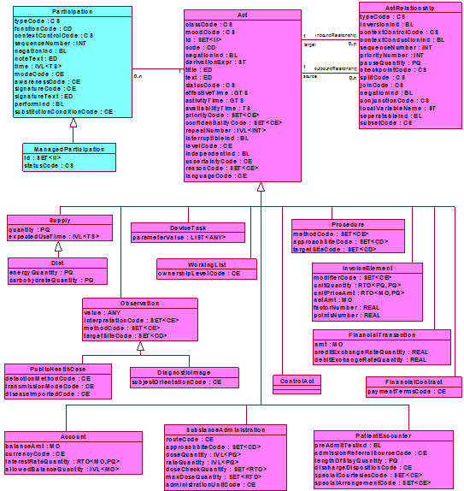

A.1.3.2.1.1.2 Act.Observation.Condition Class XML
See Figure 2: Declaring a Condition above. Note that condition is a subclass of Act.Observation not listed in the above diagram but with the same attributes as Observation.

Figure 7: Declaring an Observation
<!—condition is a subclass of Act.Observation not listed in the above diagram but with the same attributes as Observation-->
<entry>
<observation classCode='COND' moodCode='EVN'>
<id root='6a2fa88d-4174-4909-aece-db44b60a3aba'/>
<!-- How determined (CPT/LOINC/SNOMED Procedures, et cetera) -->
<code code='' codeSystem='Any' codeSystemName='Any'/>
<statusCode code='active'/><-- Computed from Status column -->
<!-- The interval of time the condition event occurred -->
<effectiveTime><low value='20050328'/></effectiveTime> <!-- computed from date column -->
<!-- What (ICD-9, ICD-10, SNOMED, MEDCIN, et cetera) -->
<value xsi:type='CV' code='44465007' codeSystem='2.16.840.1.113883.6.96' codeSystemName='SNOMED CT' >
<originalText mediaType='text/xml'>
<reference value='#problem-1'/><!-- pointer to problem in column 2 -->
</originalText>
</value>
<!-- entry Relationships follow, see next ActRelationship below -->
:
.
</observation>
</entry>

A.1.3.2.1.2 ActRelationship Class
This section describes the HL7 RIM ActRelationship Class and the associated XML pattern. The definition of the ActRelationship Class is:
“A directed association between a source Act and a target Act. ActRelationship on the same source Act are called the "outbound" act relationships of that Act. ActRelationships on the same target Act are called the "inbound" relationships of that Act. The meaning and purpose of an ActRelationship is specified in the ActRelationship.typeCode attribute.”

A.1.3.2.1.2.1 ActRelationship Class UML
This section illustrates the HL7 RIM ActRelationship Class UML. Each of the ActRelationship Class attributes have definitions as well. The most important attribute is ActRelationship.typeCode with codes and definitions described in the HL7 RIM documentation. It is beyond the scope of this document to repeat all the definitions. Please refer to the HL7 “Data Models” at www.HL7.org for these definitions.

A.1.3.2.1.2.2 ActRelationship Class XML

Figure 8: Declaring an Act Relationship
<!-- This entry relationship relates two acts from source act to target act->
<entryRelationship typeCode='REFR'>
<!-- XML of related act -->
</entryRelationship>

<!-- This entry relationship relates two acts from target act to source act. Note
the use of the inversionInd attribute to indicate the reversal of the order.
-->
<entryRelationship typeCode='REFR' inversionInd='true'>
<!-- XML of related act -->
</entryRelationship>

A.1.3.3 Building Care Structures from Classes
This section illustrates the high level UML pattern and then the XML pattern for each concept. For a full description of the UML pattern for each structure and it’s rationale, please see the HL7 Care Provision Domain, Care Structures Topic.

A.1.3.3.1 Condition Structure
A.1.3.3.1.1 Condition Structure High-level UML
This example illustrates the “Condition” related to the “Severity” observation that is used only with non-SNOMED vocabularies that have no severity modifiers, e.g. ICD-9.
ActRelationship
has Subject
Condition
Diabetes Type II

Observation
Severe

A.1.3.3.1.2 Condition Structure XML
This example illustrates the “Condition” related to the “Severity” observation that is used only with non-SNOMED vocabularies that have no severity modifiers, e.g. ICD-9.

Figure 9: Declaring a Condition
<!-- condition -->
<entry>
<observation classCode='COND' moodCode='EVN' negationInd='false'>
<!-- id Required -->
<id extension='' root=''/>
<!-- How data was obtained (CPT/LOINC/SNOMED Procedures, etc) -->
<code code='29308-4'
displayName='Diagnosis'
codeSystem='need to fill in OID'
codeSystemName='LOINC'
codeSystemVersion='xx'
/>
<statusCode>active</statusCode>
<!-- the time interval the condition was active in the patient -->
<effectiveTime low='20050329224411+0500' high=''></effectiveTime>
<!-- What data was obtained (ICD-9, ICD-10, SNOMED, etc) -->
<value
code='250.00'
displayName='Diabetes Mellitus NIDDM w/o complication'
codeSystem='Need to fill in OID'
codeSystemName='ICD-9'
codeSystemVersion='CM'
>
<originalText>Diabetes Type II</orginalText>
</value>
<!-- Severity [0..1] only used with IDC9 Codes in Condition-->
<entryRelationship typeCode='SUBJ' inversionInd=''>
<observation classCode='OBS' moodCode='EVN'>
<code code='SEV'
displayName='Severity Assessment'
codeSystem='need to fill in OID'
codeSystemName='?'
codeSystemVersion='xx'
/>

<statusCode>completed</statusCode>
<value
code='SEVR'
displayName='Severe'
codeSystem='OID'
codeSystemName='SeverityObservation'
codeSystemVersion='xxx'
>
<originalText>Severe</orginalText>
</value>
</observation>
</observation>
</entry>

A.1.3.3.2 AllergyIntolerance Structure

A.1.3.3.2.1 AllergyIntolerance Structure High-level UML
This example illustrates the relationship of the symptom in the patient to the observation of a drug reaction. That assessment is then summarized by the conclusion that the patient has an allergy. Notice how the ActRelationships produce a nested XML structure made up of Acts of the condition and observation classes.
ActRelationship
supported by
Condition
Penicillin
Allergy

Observation
Drug Reaction
ActRelationship
refers to
Observation
Urticaria (hives)

A.1.3.3.2.2 AllergyIntolerance Structure XML

Figure 10: Declaring an Allergy
<!-- Allergy -->
<entry>
<observation classCode='COND' moodCode='EVN' negationInd=''>
<!-- id Required -->
<id extension='' root=''/>
<!-- Express the Assessment Action Type-->
<code code='ADVERSE_REACTION'
displayName='Adverse Reaction Assessment'
codeSystem='OID'
codeSystemName='ObservationType'
codeSystemVersion='xx'
/>
<statusCode>active</statusCode>
<!-- The date-time the allergy first appeared in the patient-->
<effectiveTime low='20050329224411+0500' high=''></effectiveTime>
<!-- Express the allergen or irritating substance -->
<value
code='PCN'
displayName='Pennicilin'
codeSystem='OID'
codeSystemName='IntoleranceAgentValue'
codeSystemVersion='xxx'
>
<originalText><reference value='#allergy-1'/>Penicillin</orginalText>
</value>
<entryRelationship typeCode='SUBJ' inversionInd=''>
<observation classCode='OBS' moodCode='EVN'>
<code code='SEV'
displayName='Severity Assessment'
codeSystem='need to fill in OID'
codeSystemName='?'
codeSystemVersion='xx'
/>

<statusCode>completed</statusCode>
<value
code='SEVR'
displayName='Severe'
codeSystem='OID'
codeSystemName='SeverityObservation'
codeSystemVersion='xxx'
>
<originalText>Severe</orginalText>
</value>
</observation>
</entryRelationship>
<!-- Captures data about the adverse reaction detail-->
<entryRelationship typeCode='SPRT'>
<observation classCode='OBS' moodCode='EVN'>
<id/>Required
<!-- Express the Assessment Action Type-->
<code code='ADVERSE_REACTION'
displayName='Adverse Reaction Assessment'
codeSystem='OID'
codeSystemName='ObservationType'
codeSystemVersion='xx'
/>
<statusCode>completed</statusCode>
<effectiveTime/>
<!-- Express the nature of the adverse reaction-->
<value
code='C17.800.174.600'
displayName=’Drug Eruption’
codeSystem='OID'
codeSystemName='MESH'
codeSystemVersion='xx'
>
<originalText></orginalText>
</value>
<!-- primary data -->
<!-- Entry Relationship to Substance Exposure deferred to future -->
<!-- This entry relationship refers to PrimaryObservation -->
<entryRelationship typeCode='REFR'>
<observation classCode='OBS' moodCode='EVN' negationInd=''>
<!-- id Required -->
<id extension='' root=''/>
<code code='10206-1'
displayName='Physical Finding-SKIN'
codeSystem='OID'
codeSystemName='LOINC'
codeSystemVersion='xx'
/>
<originalText></orginalText>
<statusCode>completed</statusCode>
<effectiveTime/>
<value
code='need ICD code'
displayName='Urticaria'
codeSystem='OID'
codeSystemName='ICD9'
codeSystemVersion='DM'
>
<originalText>Urticaria</orginalText>
</value>
</observation>
</entryRelationship>
</observation>
</entryRelationship>

</observation>
</entry>

A.1.3.3.3 Medication Structure
A.1.3.3.3.1 Medication Structure High-level UML
This example illustrates the relationship of substance administration action to the substance being administered. In this case, the manufactured material in the role of a product is an HL7 Entity-Role subclass relation rather than an Act. Instead of ActRelationship, the association class between the two main classes is the Participation class. For an explanation of these additional classes, please refer to the HL7 “Data Models” at www.HL7.org. However, the XML is similar to the former examples.
Participation
consumes
Substance Administration
Manufactured Product

A.1.3.3.3.2 Medication Structure XML

Figure 11: Declaring a Medication
<!-- Medication -->
<entry>
<substanceAdministration classCode='SBADM' moodCode='RQO'>
<!-- id Required -->
<id extension='' root=''/>
<code code=''
displayName=''
codeSystem='OID'
codeSystemName=''
codeSystemVersion='xx'
>
<!-- References original text in another location: Penicillin 500mg qid X 10 days-->
<originalText><reference value='' mimeType=''/></orignalText>
</code>
<statusCode>active</statusCode>
<!-- The time interval the medication is ordered for-->
<effectiveTime low='20050329224411+0500' high='time 10 days later put in datetimestamp' frequency ‘qid’ NEED to Research GTS for proper expression ></effectiveTime>
<routeCode
code='PO'
displayName='PO'
codeSystem='OID'
codeSystemName='RouteCode'
codeSystemVersion='xxx'
>
<!-- References original text in another location: PO-->
<originalText><reference value='#foo1' mediaType='text/xml'/></originalText>
</routeCode>
<approachSiteCode
code=''
displayName=''
codeSystem=''
codeSystemName=''
codeSystemVersion=''
>
<!-- References original text in another location: -->
<originalText><reference value='#foo1' mediaType='text/xml'/></originalText>
</approachSiteCode>*
<doseQuantity>
500mg
</doseQuantity>
<rateQuantity>
Help me!
</rateQuantity>
<text><reference value='#foo' mediaType='text/xml'/></text>
<!-- deviates from Care Structures but conforms to CDA R2 -->
<consumable typeCode='CSM'>
<manufacturedProduct classCode='MANU'>
<manufacturedLabeledDrug>
<code
code=''
displayName='PenicillinVK 500mg'
codeSystem=''
codeSystemName=''
codeSystemVersion=''
>
<originalText><reference value='#foo1' mediaType='text/xml'/>Penicillin VK 500mg</originalText>
</code>
<name>Penicillin</name>
</manufacturedLabeledDrug>
</manufacturedProduct>
</consumable>
<!-- Comments -->
<entryRelationship typeCode='SUBJ' inversionInd=''>
<act classCode='OBS' moodCode='EVN'>
<code>ActCode???</code>
<text>Text of the comment</text>
<statusCode>completed</statusCode>
</act>
</entryRelationship>
</substanceAdministration>
</entry>

A.1.3.3.4 External File Reference Structure
A.1.3.3.4.1 External File Reference Diagrams
There are cases where a document (called the source document) needs to contain references to one or more separate documents (called the target document).
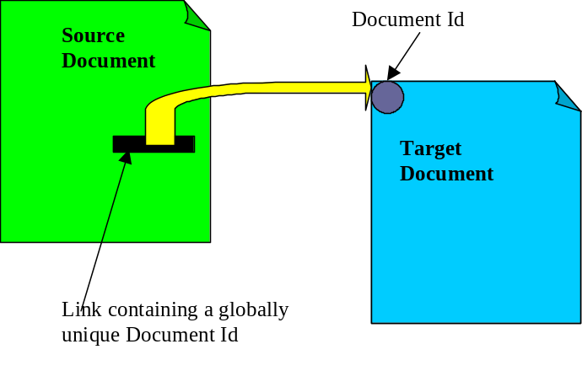
Such a referencing mechanism is specified in a manner so that:
- The producer of a document shall be able to create links to target documents. The link within the source document need not be updated when the source or the target documents are relocated as part of their communication, storage or archival. This results in particular in two important properties:
  - The link in the source document need not be changed when a document consumer is retrieving the target document and may chose to store such document
  - A document consumer should be able to determine that the target document may be locally stored without any XDS Registry queries
  - A document consumer may use this link to query an affinity domain XDS document registry to allow retrieval of the document location (to retrieve the corresponding target document) and its metadata to support local application decisions (e.g. characteristics of the document, compatibility with display capabilities, link rendering).
- Within an XDS affinity domain, the links in the source documents need not be updated when the source or the target documents go through their documents lifecycle (addendum, replacement, transform, deprecated).

When a referencing document is a CDA Release 2 document, the link in the source document uses an External Document construct that contains a globally unique document identifier. When shared in an XDS Affinity Domain, CDA Release 2 documents shall use the “XDSdocumentId ” attribute in the document registry (constraint for all CDA release 2 document content profiles), so that when queried, the XDS Registry may return the associated Document Metadata, including the information needed to retrieve the document from the XDS Repository where stored.
The Figure below illustrates the case where a document consumer displays a document that contains a link (called source document), uses the Document Id in the link to find from the XDS Document Registry, the location (URL) of the target document (1) and retrieve the target document (2) from an XDS Document Repository.

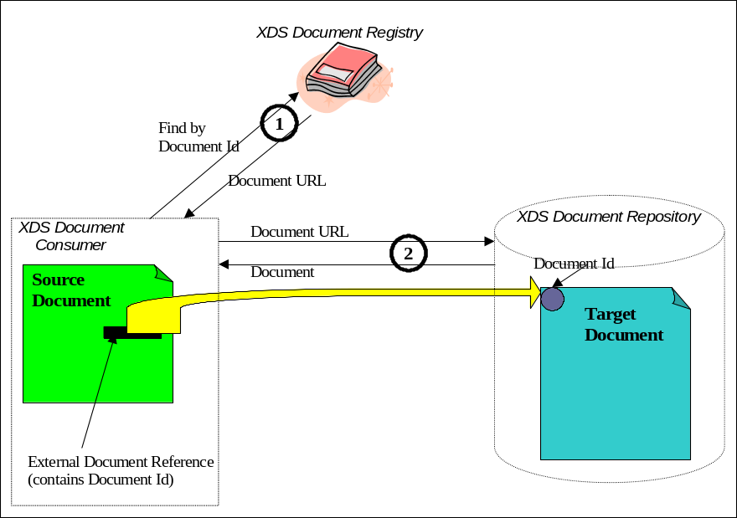

Once the document consumer has stored internally a source document and linked target document, the link via the Document Id of the target document can still be used within the system that acted as a document consumer. This is depicted in the figure below. The manner in which the system internally resolves the link to locate the target document Id is an implementation specific problem outside the scope of IHE. Note that there is no need for any interaction with the XDS Document Registry in order to resolve the link.
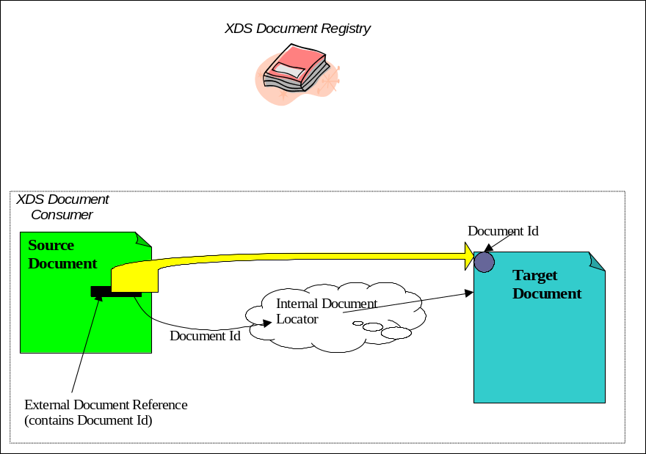

The construct used to imbed into a document a link to another document is specific to different document format standard. For example DICOM has standardized in its specific syntax the construct to include a Document Id (SOP Instance UID) to link to target DICOM Documents.
As XDS Document Id is a rather general mechanism to manage in a document registry unique document identifiers, and XDS document have to be uniquely identified, the use of links within documents pointing to other targets documents of the same format or different standard is possible in XDS Affinity Domains, as long as Source Document offer a construct to include a globally unique document Id.

NAV should supply a “notification event” code, so that receivers can initiate different processing activities based on this code. XDS-MS will not track this workflow related event, which is expected to be consistent with the XDS Submission Set contentCode that is tracked by the XDS Document Registry.
The coding system OID and values were not available at the time of this writing, values will be provided for trial implementation.
Values were not available at the time of this writing. Values will be provided for trial implemetation.

